NEPAC Data Retriever Software Task Template

# Version: 09.24.21

# Overview

The NEPAC Data Retriever application serves as the first step in the operation of the NASA Evolutionary Programming Analytic Center (NEPAC) application. The goal of NEPAC Data Retriever is as follows:

1. Take rows of data containing date, time, location and Chl-a levels as input.
2. Take lists of remote sensing missions/instrument sources as additional input.
3. Perform temporal and spatial queries of data sources to determine which data is necessary given the input.
   1. Download the necessary data (which is in NetCDF form).
4. Extract desired data and append the retrieved data to the data given as input.

This task is expected to run in the nepac (production) container.

**Download datasets to source code:**

In the source code, a set of datasets is needed. Due to GitHub’s file size limit, these files are not immediately included with a `git clone` command. Steps are outlined below to retrieve the necessary files into the correct location.

# This needs to happen *after* the repository is cloned.

$ cd desired/directory/

$ tar -xvzf /att/nobackup/cssprad1/nepac_datasets.tar.gz -C nepac/model/datasets/

# Repository

* nepac

# Branch Name

* release/1.0.1

# Container

* /att/nobackup/iluser/containers/nepac.sif

# Software Design

* Model
  + CmrProcess.py
  + NepacProcess.py
  + NepacProcessCelery.py
  + Retriever.py
  + OceanColorRetriever.py
  + BosswRetriever.py
  + EtopoRetriever.py
  + OcSWFHICOOCTRetriever.py
  + OisstRetriever.py
  + OccciRetriever.py
  + PosstRetriever.py
  + ILProcessController.py
* View
  + NepacCommandLineView.py
  + NepacProcessGUI.py
* Controller

# Tests

*List the unit or application tests that validate the code in this task.*

* python -m unittest discover nepac/model/tests

For NEPAC DR Command Line Interface (CLI) –

Note: Not applicable to NEPAC DR Graphical User Interface (GUI).

|  |  |  |  |
| --- | --- | --- | --- |
| Parameter | Required | Description | Sample |
| --celery | No | The option to use celery to distribute the tasks. | --celery |
| -no_data | No | No data value. | 9999 |
| -errored_data | No | Data value to set when NEPAC DR encounters an error. | 9888 |
| -f | Yes | Path to input file with time, date, location, and Chl-a values. | input/nepacInput.csv |
| -o | No | Output directory path. | output/ |
| -md_file | Yes | Use this if the user would like to give NEPAC a file with Mission:Dataset on each line. Examples of a file would look like:  MODIS-Terra:Rrs_443  MODIS-Aqua:ipar  where each Mission:Dataset combo is a new line. | input/nepacProductInput.txt |
| -d | Yes | Path to dummy datasets. | input/datasets/ |

See Appendix A-D for sample input/output.

# Files

* containers.nepac.def
* view.NepacCommandLineView.py
* view.NepacProcessGUI.py
* model.OceanColorRetriever.py
* model.ILProcessController.py
* model.NepacProcess.py
* model.NepacProcessCelery
* model.BosswRetriever
* model.CmrProcess.py
* model.EtopoRetriever.py
* model.OcSWFHICOOCTRetriever.py
* model.OccciRetriever.py
* model.OisstRetriever.py
* model.PosstRetriever.py
* model.RetrieverBase.py
* model.tests.test_BosswRetriever.py
* model.tests.test_CmrProcess.py
* model.tests.test_EtopoRetriever.py
* model.tests.test_OcSWFHICOOCTRetriever.py
* model.tests.test_OccciRetriever.py
* model.tests.test_OisstRetriever.py
* model.tests.test_PosstRetriever.py
* model.tests.test_OceanColorRetriever.py
* model.tests.test_NepacProcess.py
* model.tests.nepacTestSampleInputOne.txt
* model.tests.Application Test Template Nepac.docx
* model.datasets.README.md

**Appendix A. NEPAC Data Retriever GUI Invocation**

Note: Make sure X11 forwarding is enabled. See Appendix C for text version.

Untar dummy datasets to desired directory:

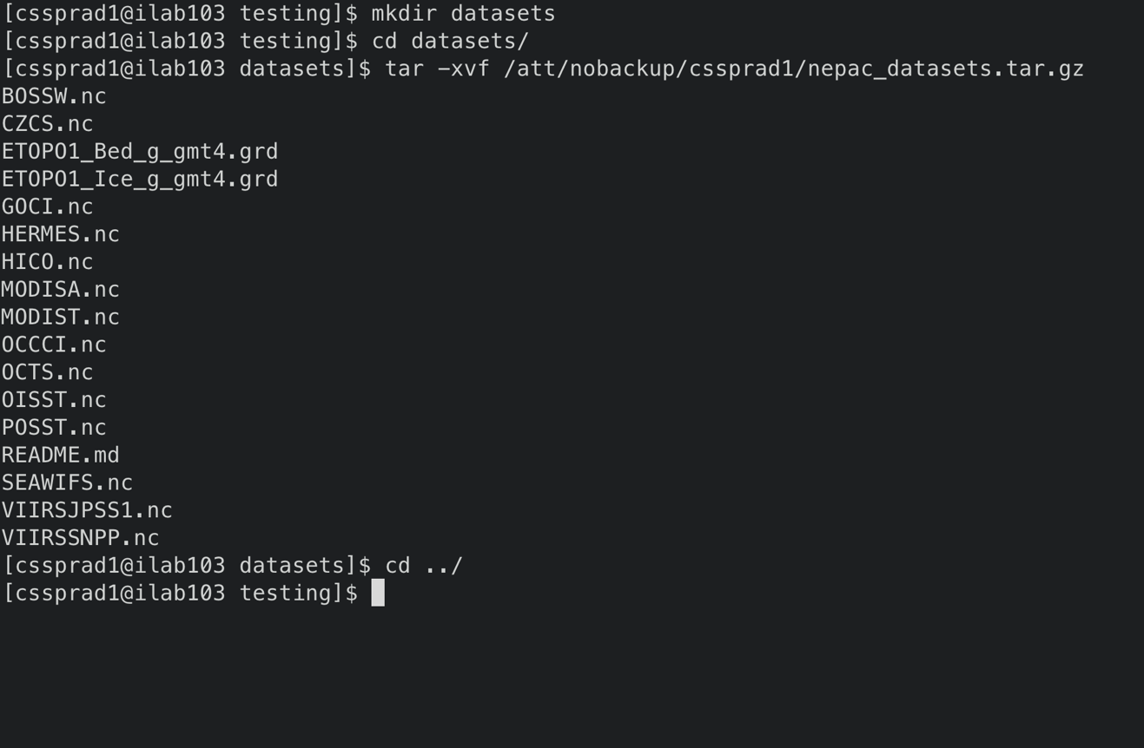

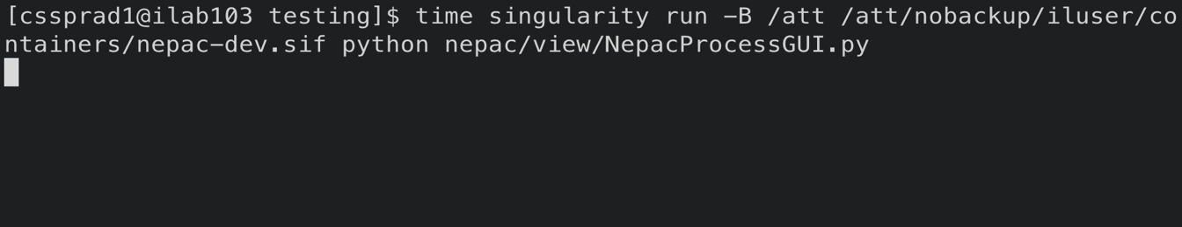

This will then open up an X11 GUI window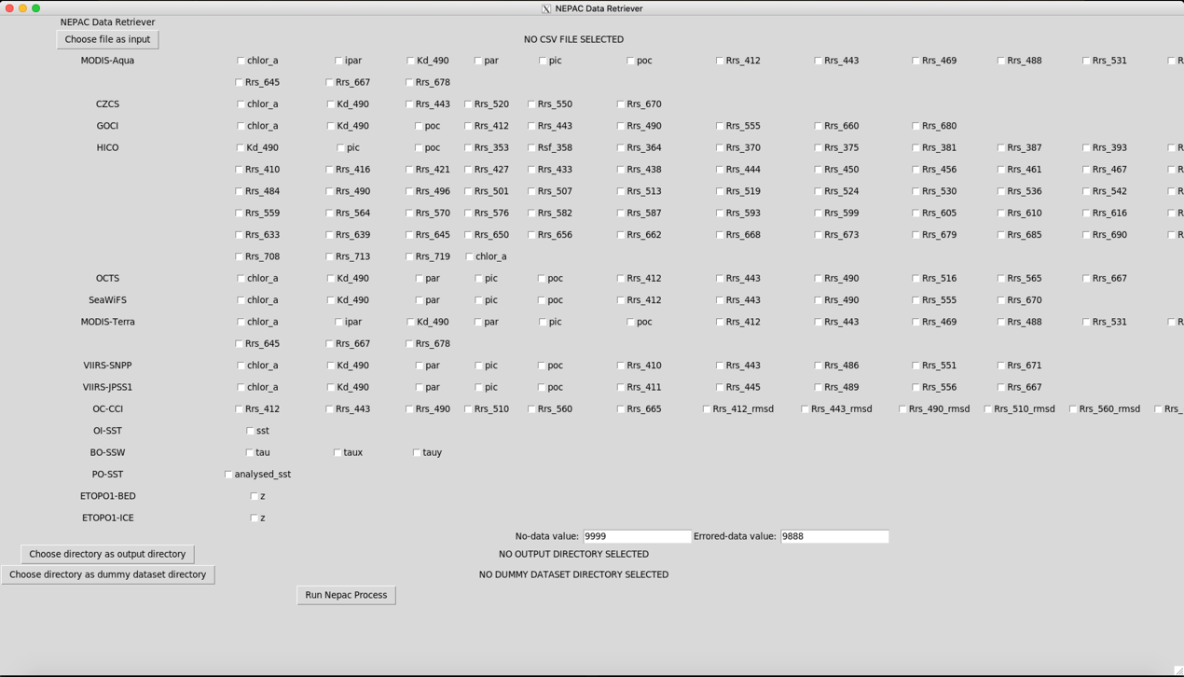

Select input csv: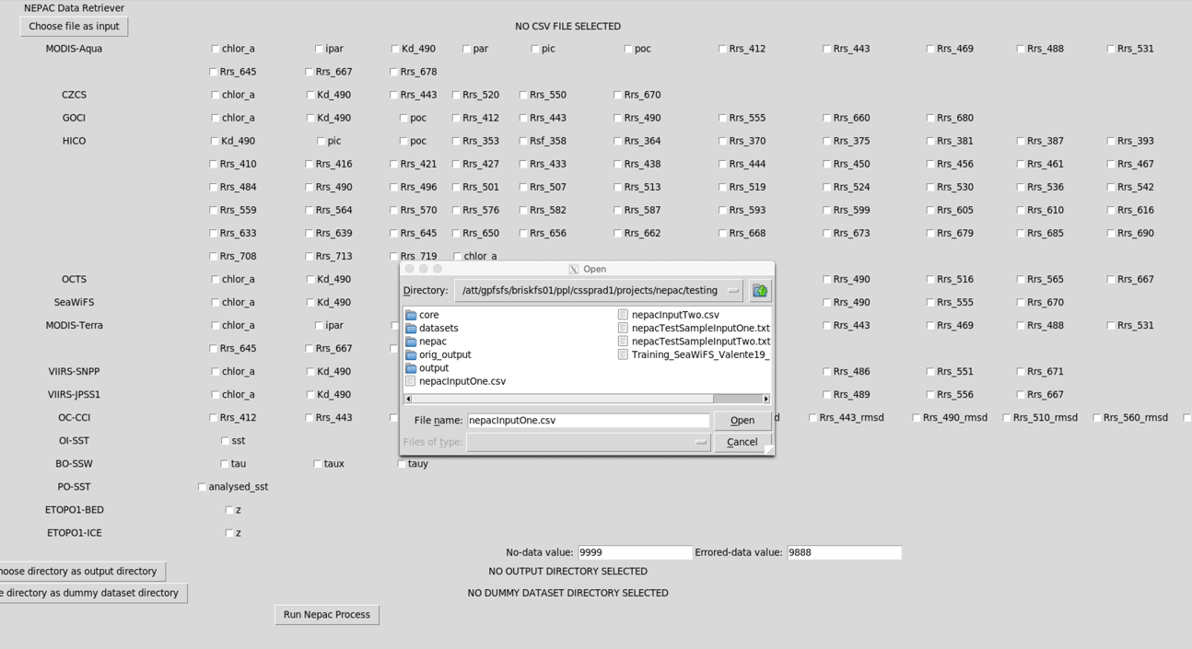

**Select data products:**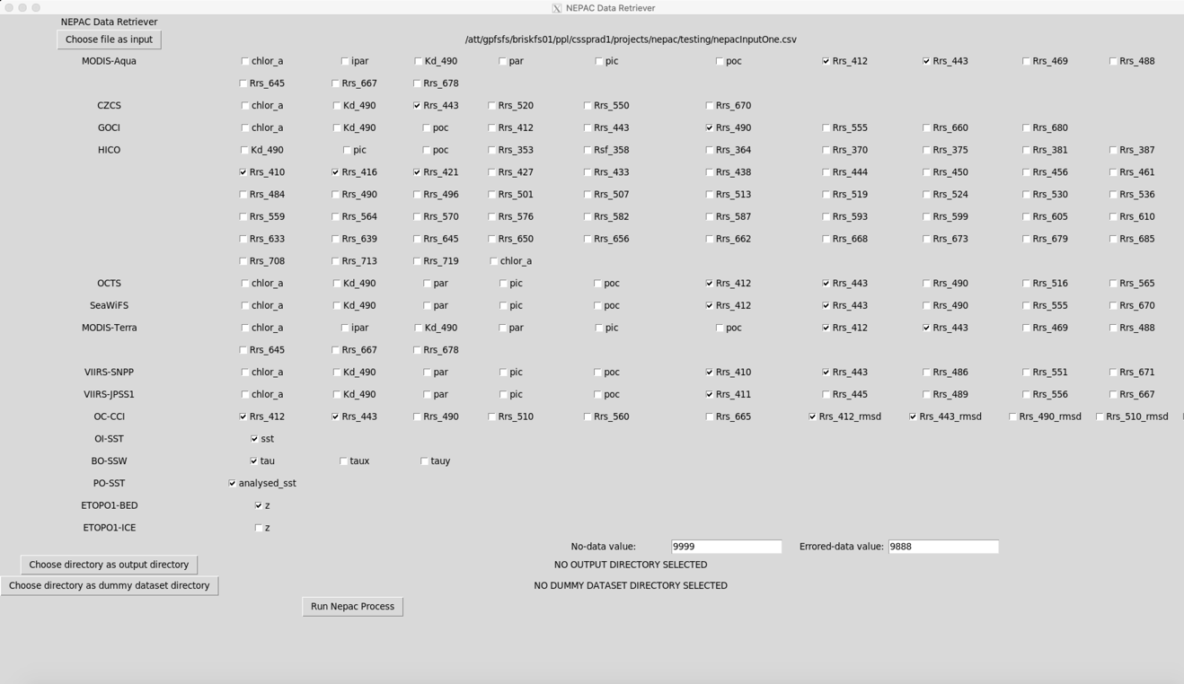

**Select output directory:**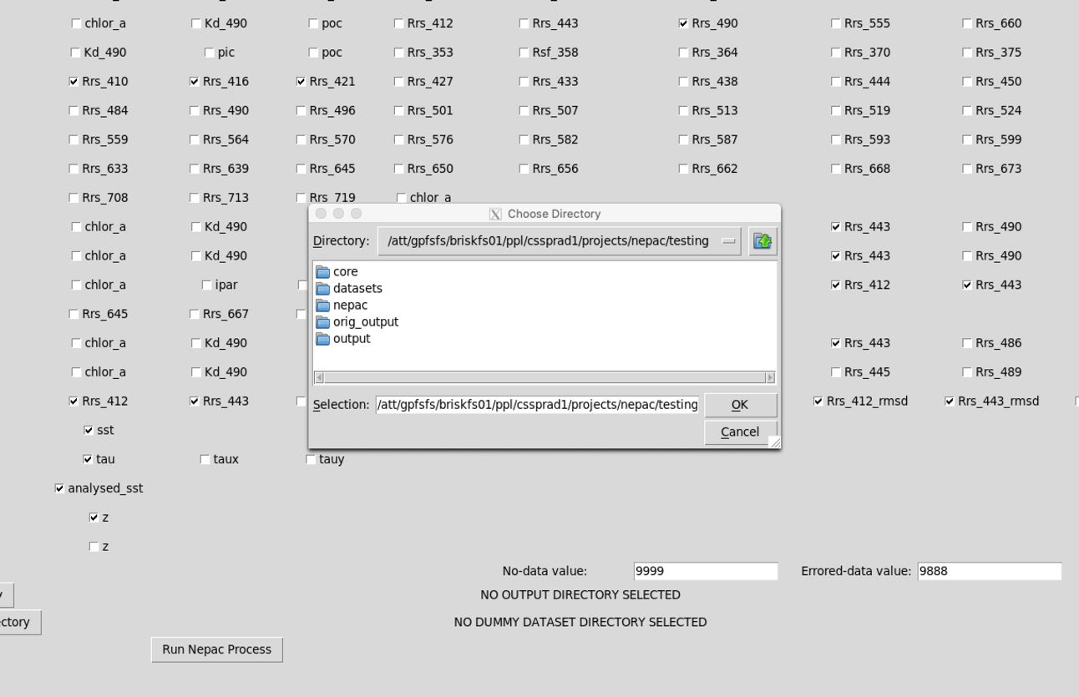

Select dummy dataset directory (this is the directory we untarred in the second step of the task):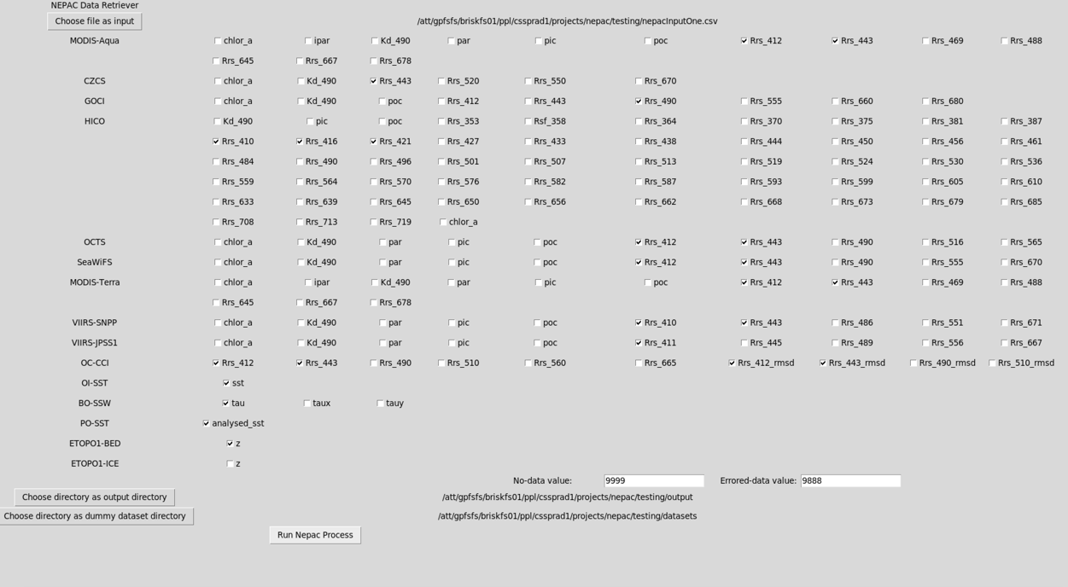

Click “Run Nepac Process”, you’ll then see a lot of shell output from the shell that you ran the invocation command:

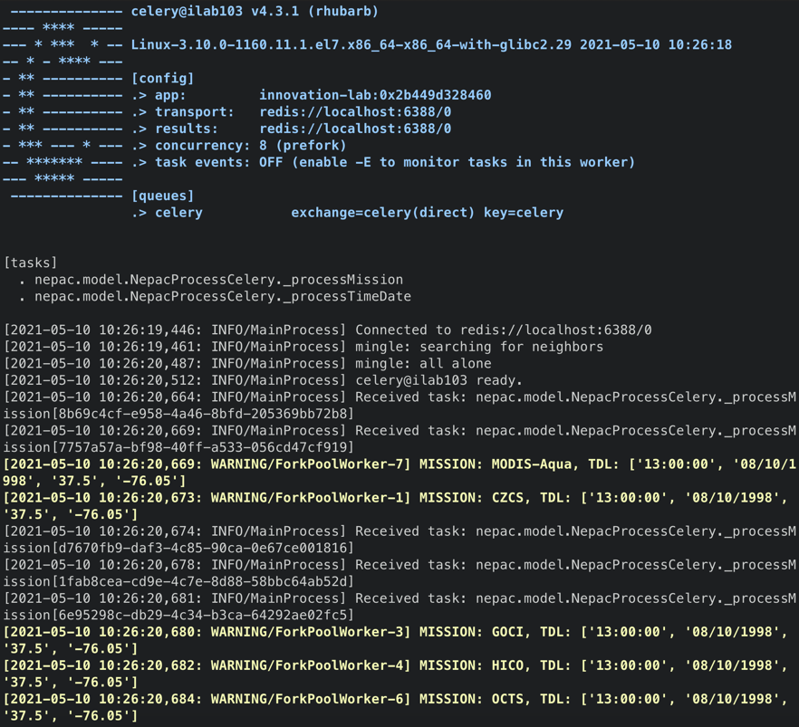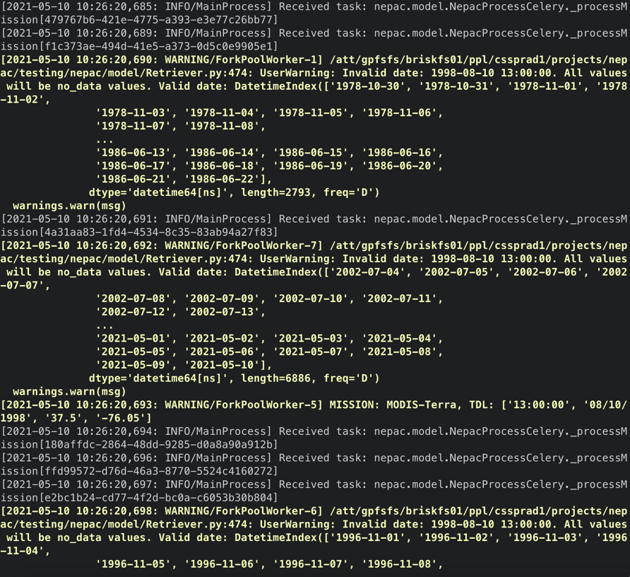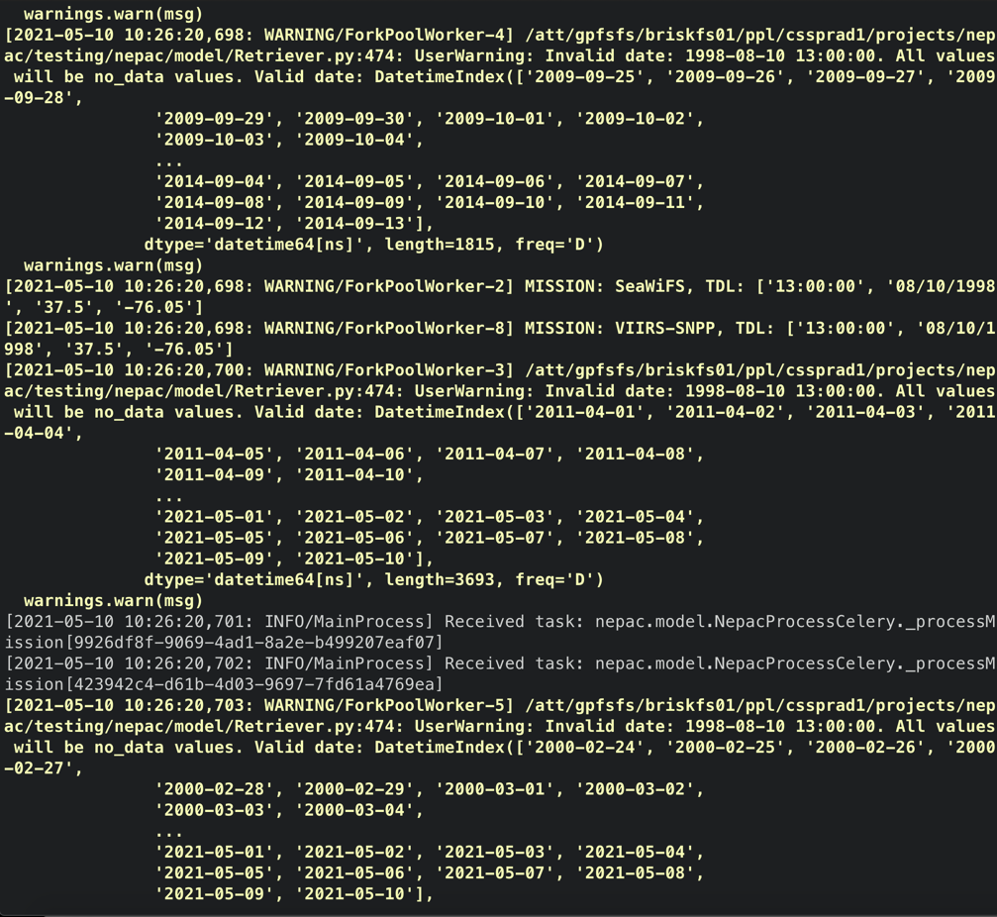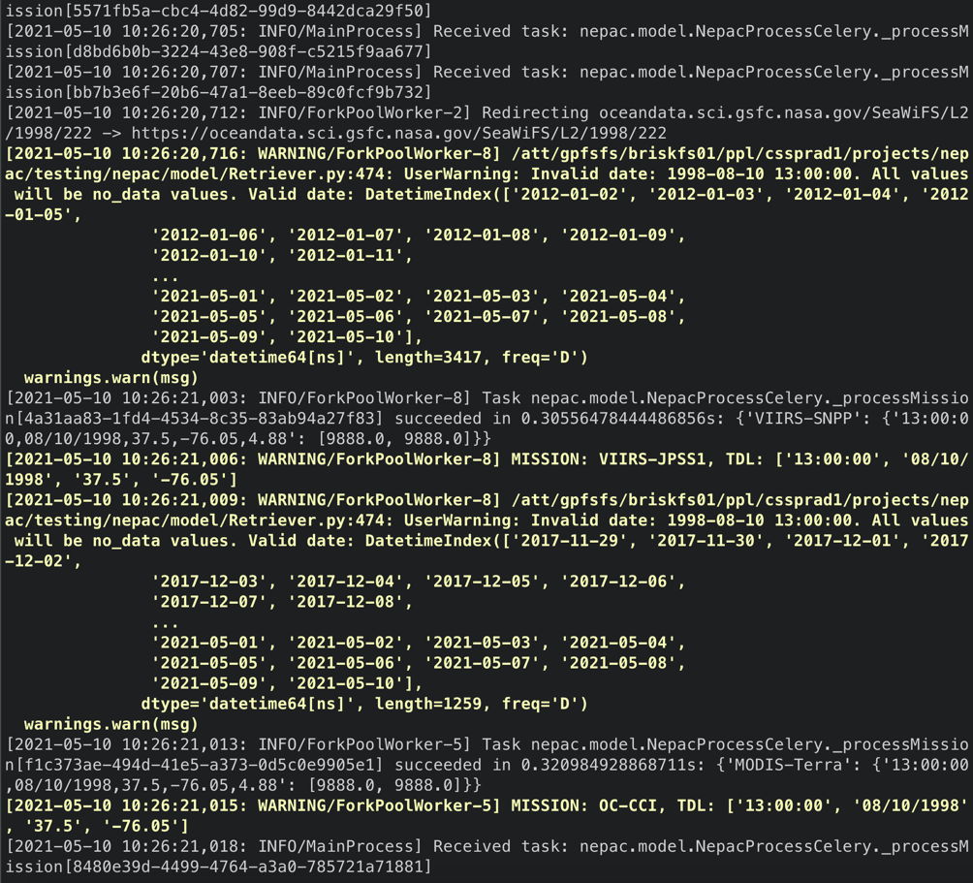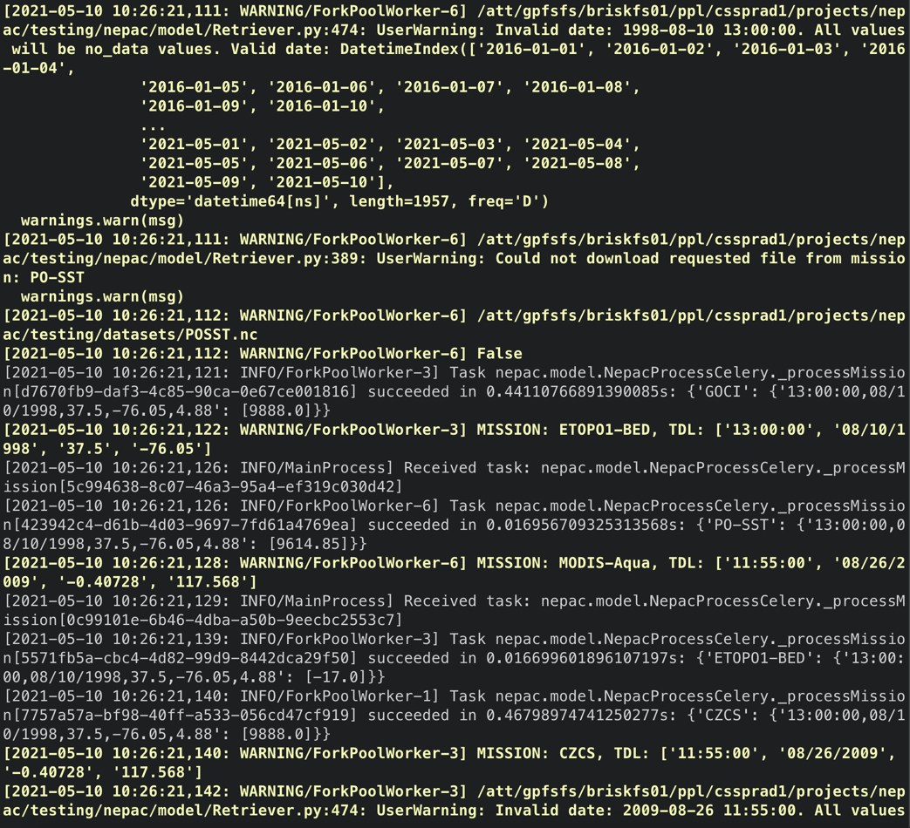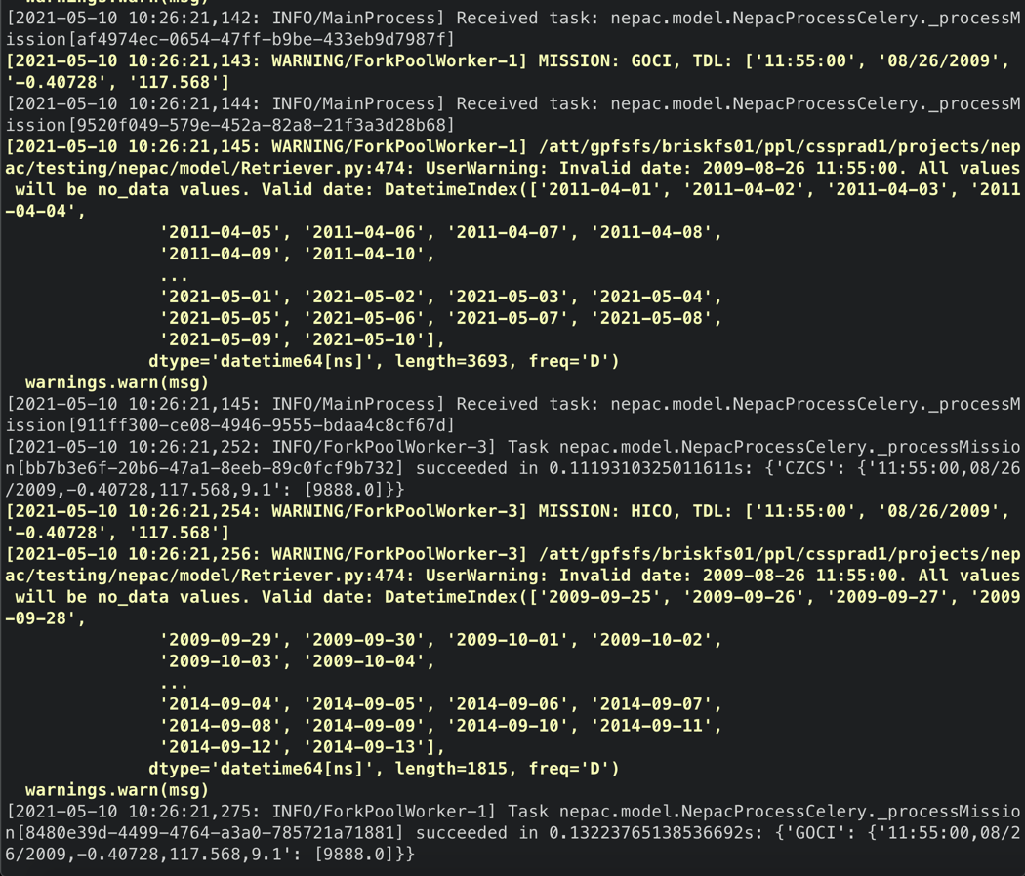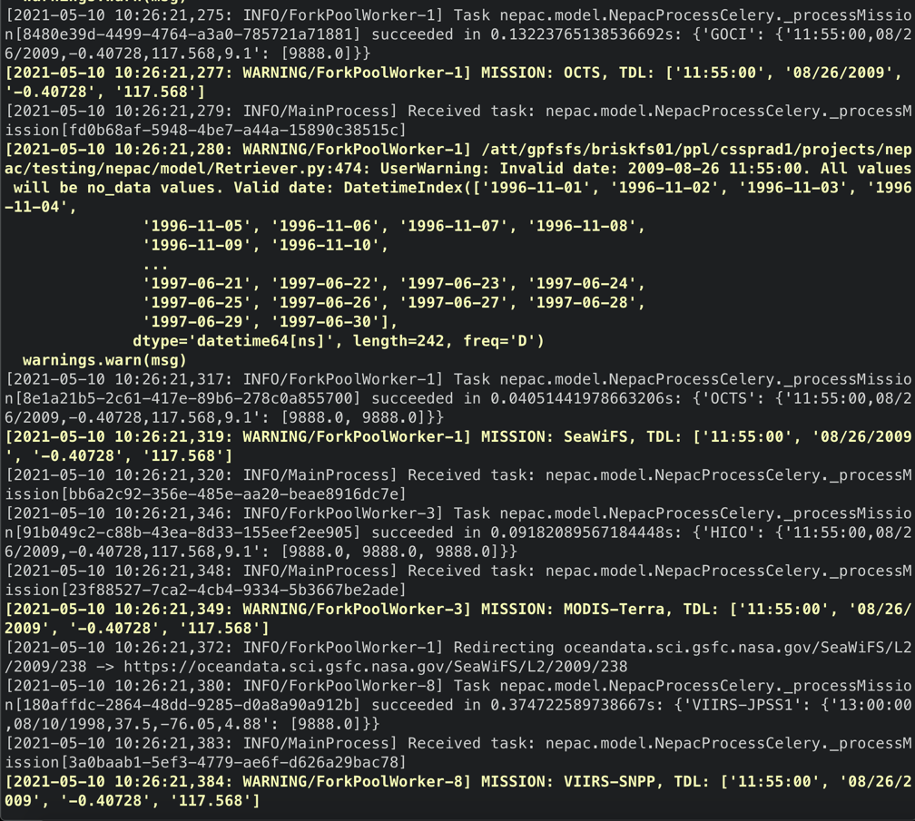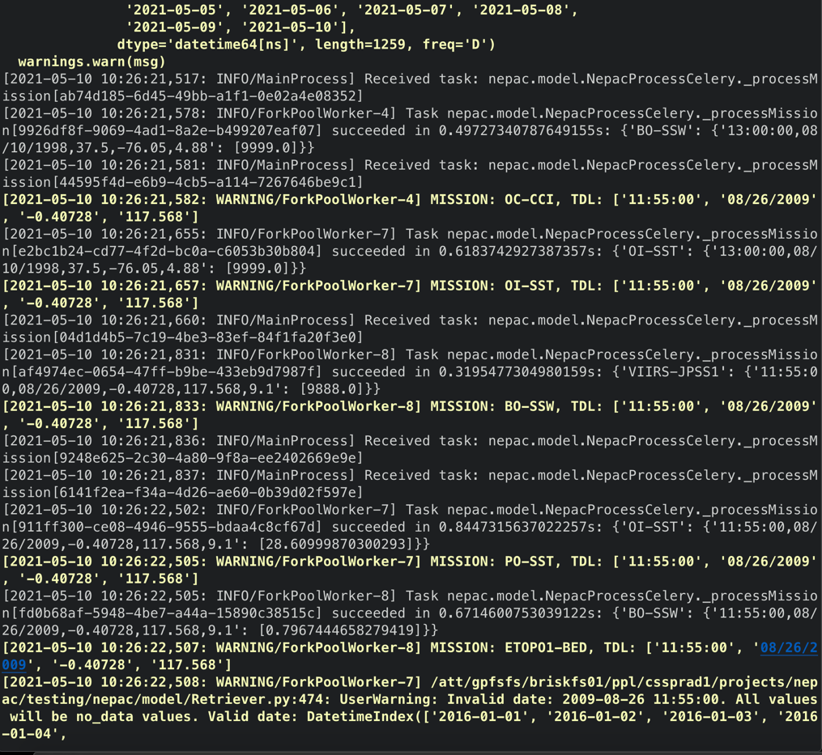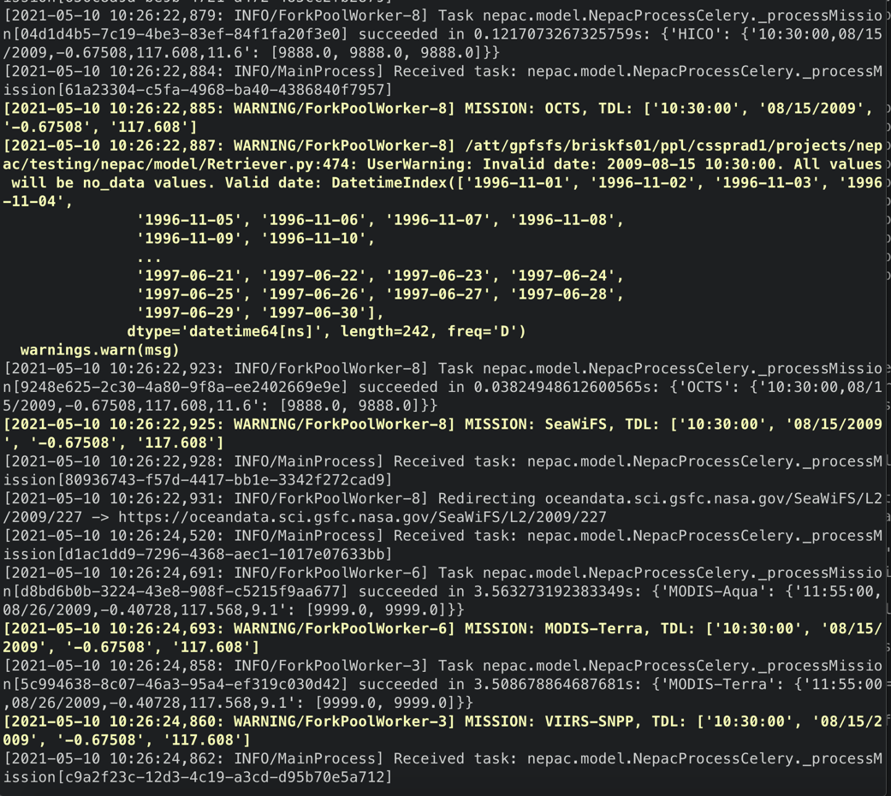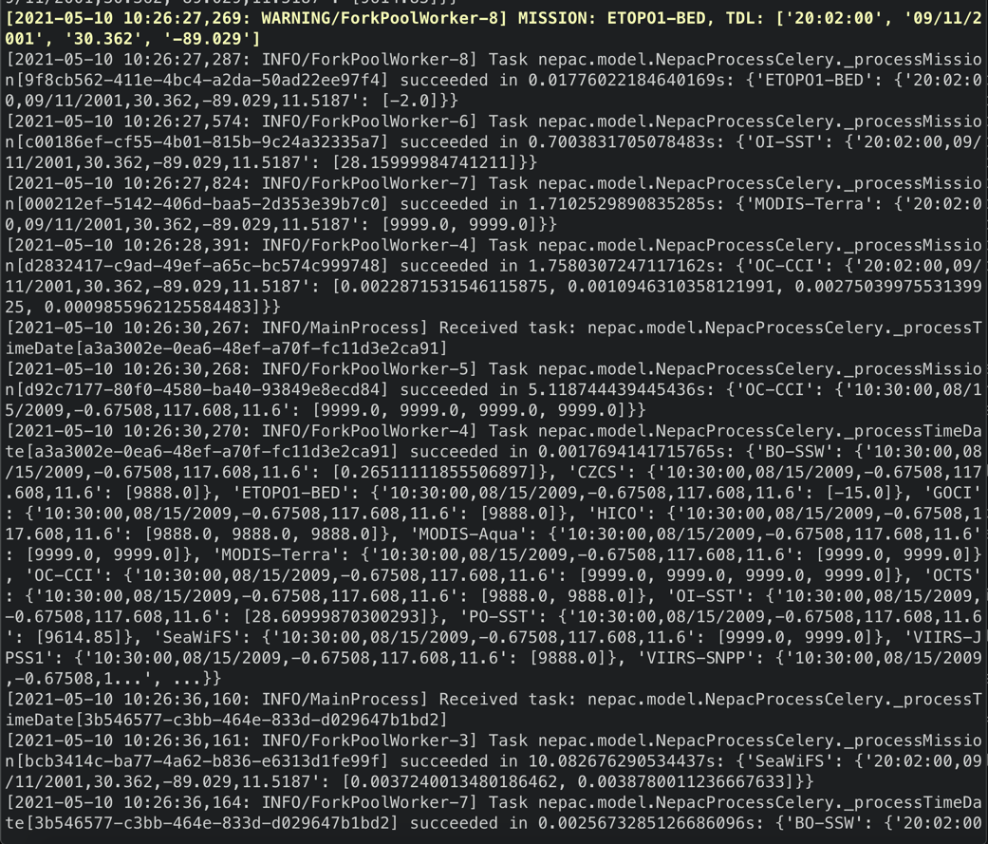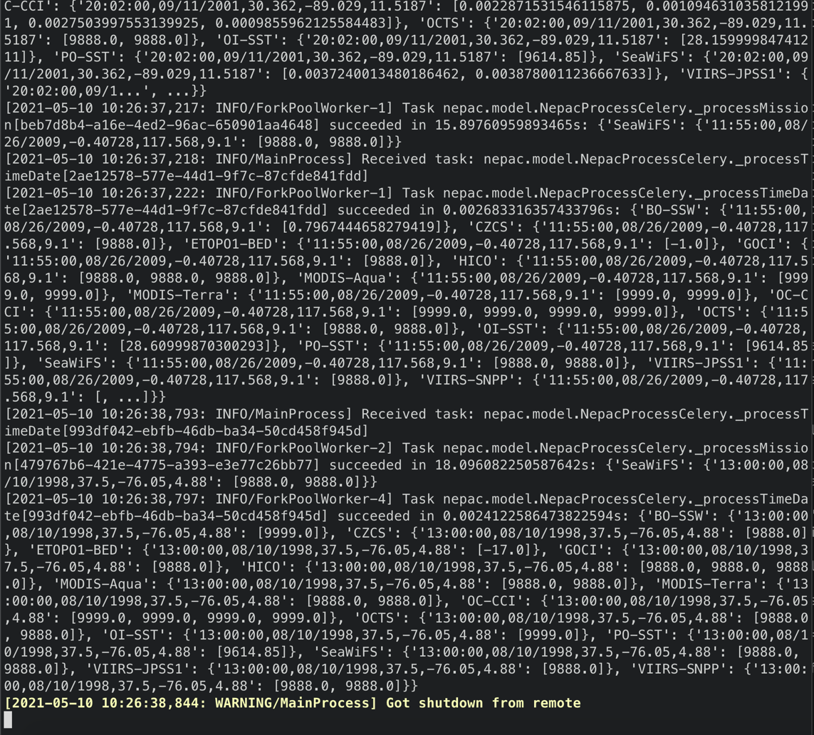

Once you see the last line, you may exit the GUI. Moving to the output directory, we can see an output CSV.

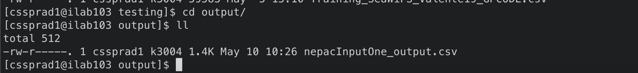

**Appendix B. NEPAC Data Retriever Command Line Interface (CLI) Invocation.**

Note: See Appendix D for text version.

Write a file that lists the data products desired from NEPAC DR.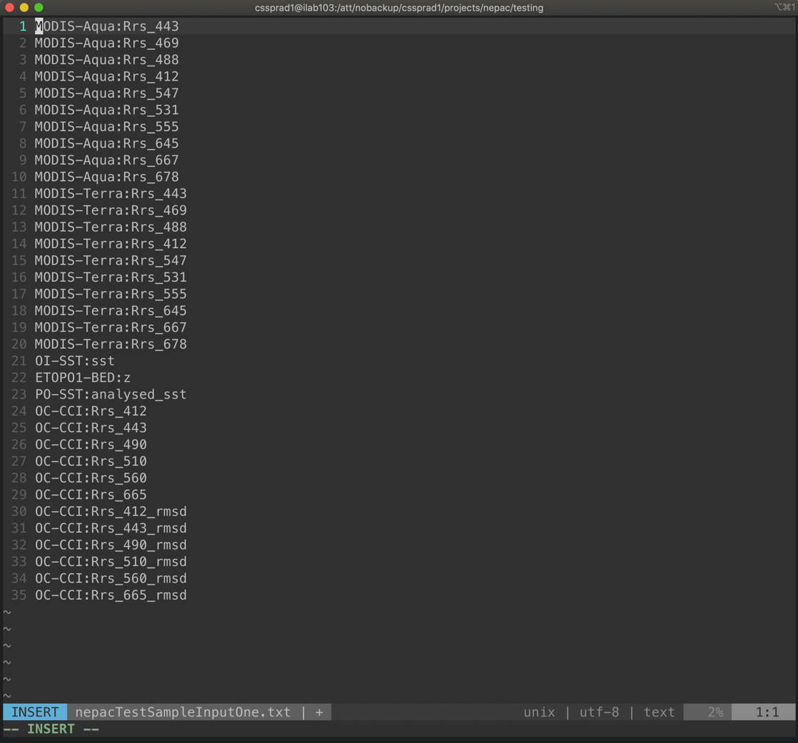

Untar dummy dataset directory:

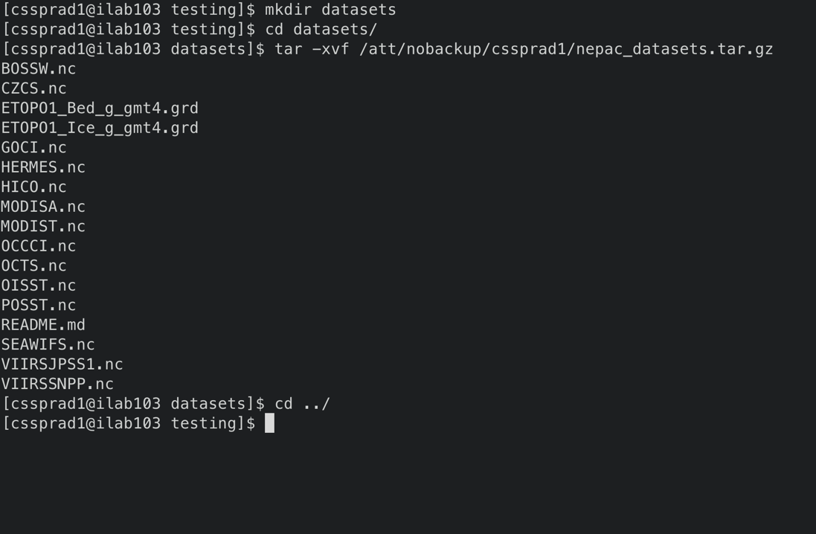

Invoke NEPAC DR:

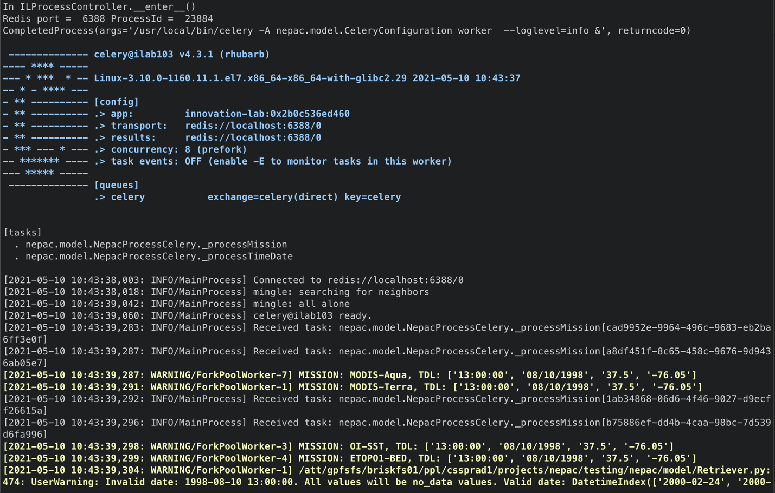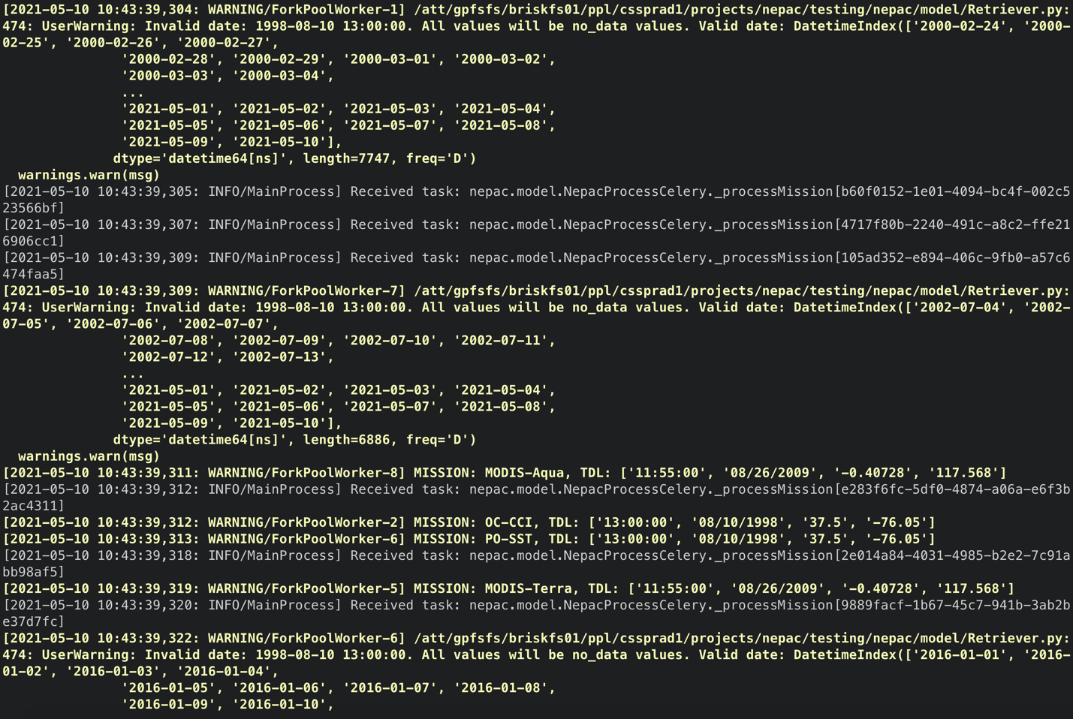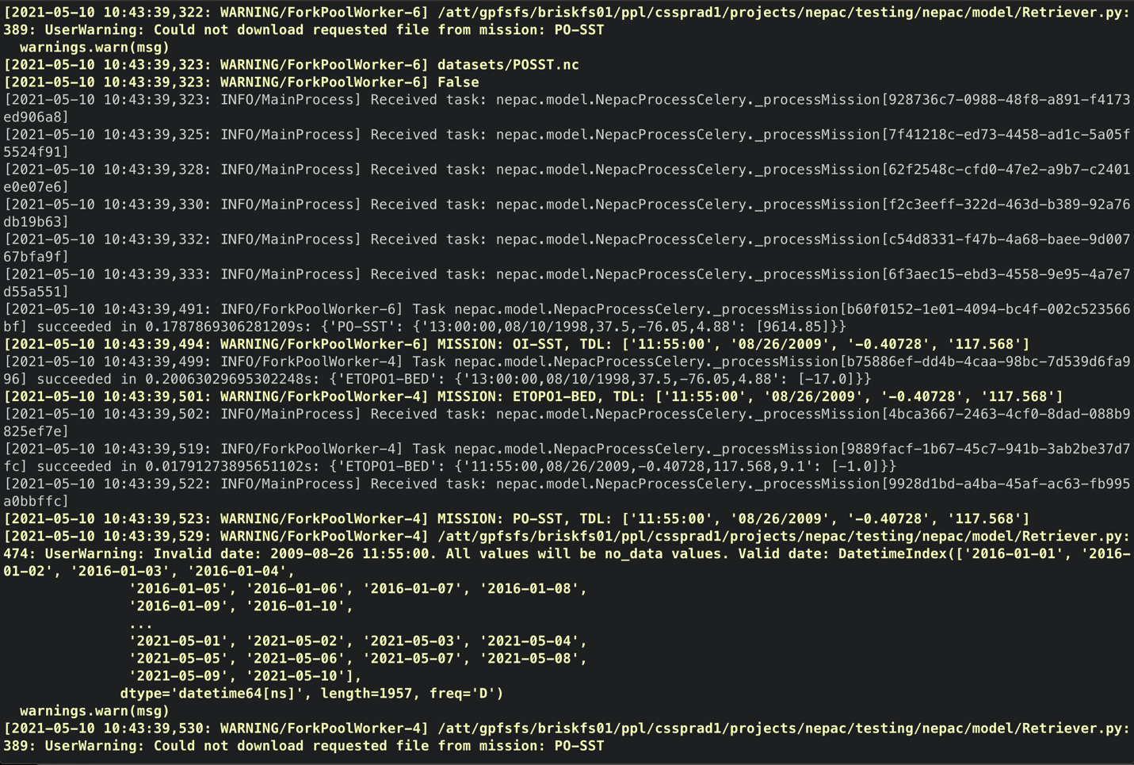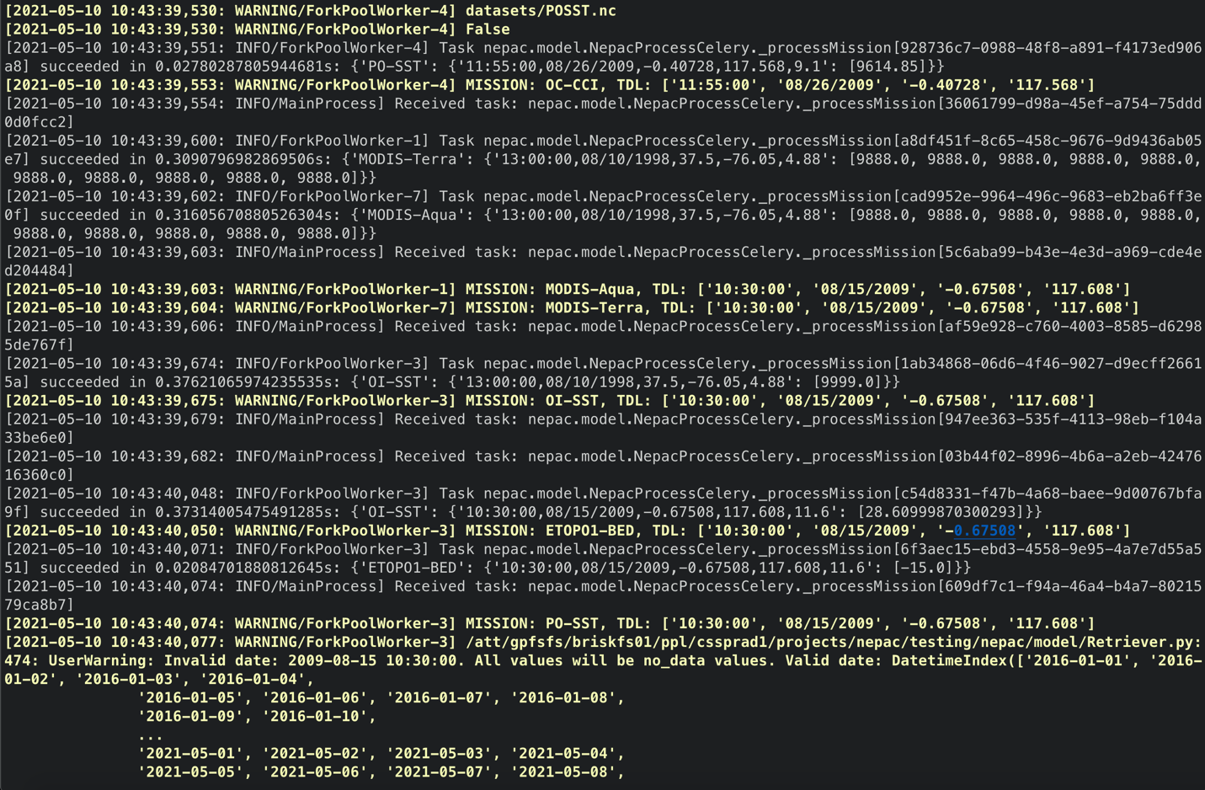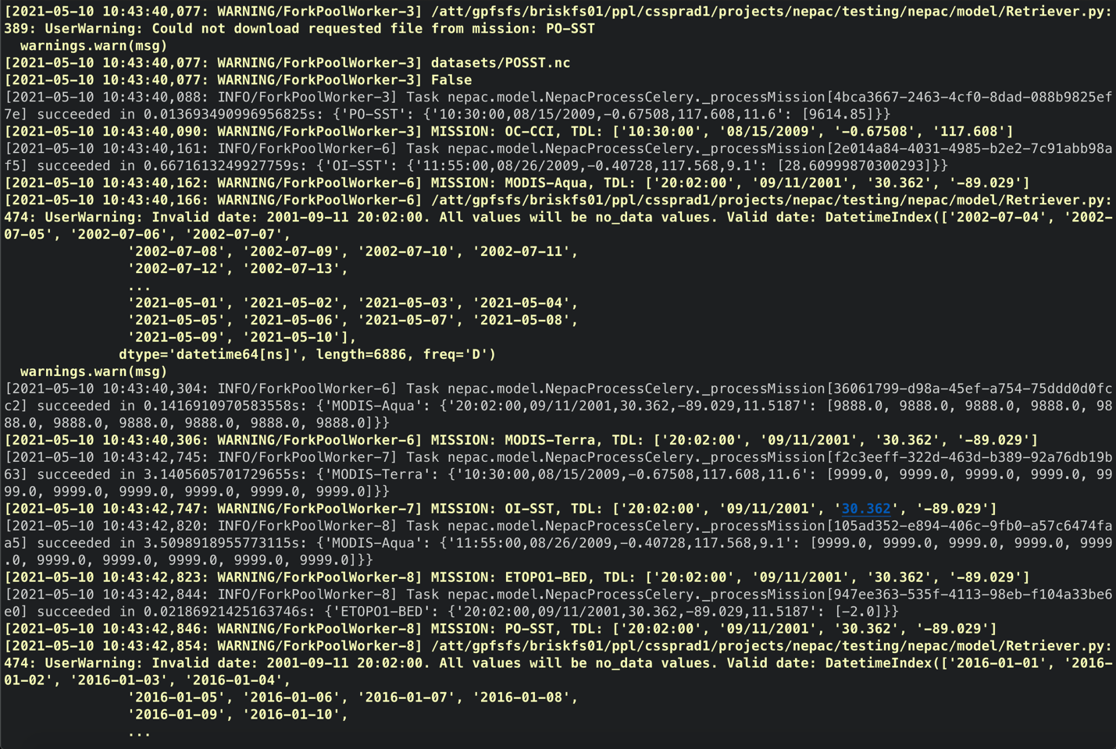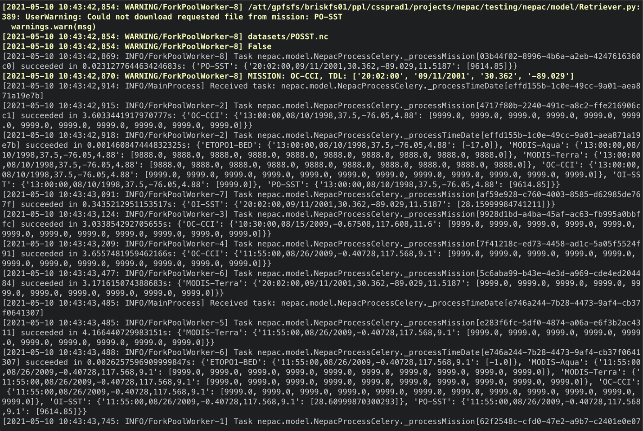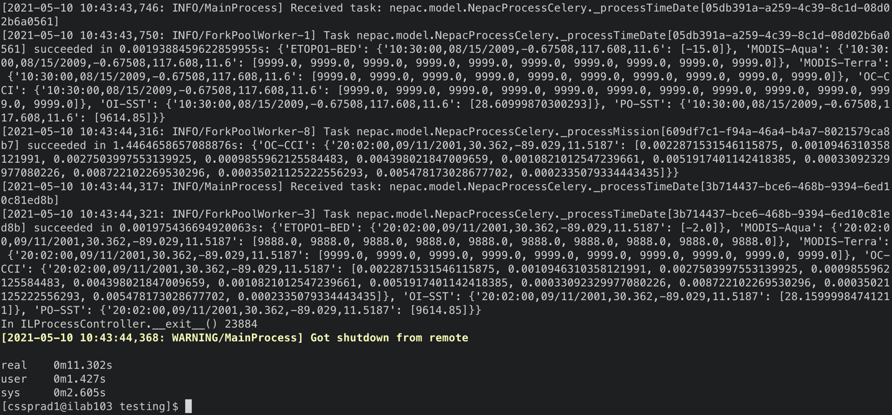

**Appendix C. NEPAC DR GUI Invocation, Text**

[cssprad1@ilab103 testing]$ mkdir datasets

[cssprad1@ilab103 testing]$ cd datasets/

[cssprad1@ilab103 datasets]$ tar -xvf /att/nobackup/cssprad1/nepac_datasets.tar.gz

BOSSW.nc

CZCS.nc

ETOPO1_Bed_g_gmt4.grd

ETOPO1_Ice_g_gmt4.grd

GOCI.nc

HERMES.nc

HICO.nc

MODISA.nc

MODIST.nc

OCCCI.nc

OCTS.nc

OISST.nc

POSST.nc

README.md

SEAWIFS.nc

VIIRSJPSS1.nc

VIIRSSNPP.nc

[cssprad1@ilab103 datasets]$ cd ../

[cssprad1@ilab103 testing]$ time singularity run -B /att /att/nobackup/iluser/containers/nepac-dev.sif python nepac/view/NepacProcessGUI.py

-------------- celery@ilab103 v4.3.1 (rhubarb)

---- **** -----

--- * *** * -- Linux-3.10.0-1160.11.1.el7.x86_64-x86_64-with-glibc2.29 2021-05-10 11:02:41

-- * - **** ---

- ** ---------- [config]

- ** ---------- .> app: innovation-lab:0x2b373a567460

- ** ---------- .> transport: redis://localhost:6388/0

- ** ---------- .> results: redis://localhost:6388/0

- *** --- * --- .> concurrency: 8 (prefork)

-- ******* ---- .> task events: OFF (enable -E to monitor tasks in this worker)

--- ***** -----

-------------- [queues]

.> celery exchange=celery(direct) key=celery

[tasks]

. nepac.model.NepacProcessCelery._processMission

. nepac.model.NepacProcessCelery._processTimeDate

[2021-05-10 11:02:42,146: INFO/MainProcess] Connected to redis://localhost:6388/0

[2021-05-10 11:02:42,160: INFO/MainProcess] mingle: searching for neighbors

[2021-05-10 11:02:43,186: INFO/MainProcess] mingle: all alone

[2021-05-10 11:02:43,207: INFO/MainProcess] celery@ilab103 ready.

[2021-05-10 11:02:43,446: INFO/MainProcess] Received task: nepac.model.NepacProcessCelery._processMission[94f08a53-ebac-415a-8d9e-7855e9d3f66a]

[2021-05-10 11:02:43,450: WARNING/ForkPoolWorker-7] MISSION: MODIS-Aqua, TDL: ['13:00:00', '08/10/1998', '37.5', '-76.05']

[2021-05-10 11:02:43,451: INFO/MainProcess] Received task: nepac.model.NepacProcessCelery._processMission[6d49e1a4-fa78-49f9-9b39-f0ec8c6a9009]

[2021-05-10 11:02:43,454: WARNING/ForkPoolWorker-1] MISSION: CZCS, TDL: ['13:00:00', '08/10/1998', '37.5', '-76.05']

[2021-05-10 11:02:43,462: INFO/MainProcess] Received task: nepac.model.NepacProcessCelery._processMission[f04cb33d-1171-4b8f-bf36-3161babbf51b]

[2021-05-10 11:02:43,465: INFO/MainProcess] Received task: nepac.model.NepacProcessCelery._processMission[29555871-0207-4634-9b07-4034f55bed98]

[2021-05-10 11:02:43,466: WARNING/ForkPoolWorker-7] /att/gpfsfs/briskfs01/ppl/cssprad1/projects/nepac/testing/nepac/model/Retriever.py:474: UserWarning: Invalid date: 1998-08-10 13:00:00. All values will be no_data values. Valid date: DatetimeIndex(['2002-07-04', '2002-07-05', '2002-07-06', '2002-07-07',

'2002-07-08', '2002-07-09', '2002-07-10', '2002-07-11',

'2002-07-12', '2002-07-13',

...

'2021-05-01', '2021-05-02', '2021-05-03', '2021-05-04',

'2021-05-05', '2021-05-06', '2021-05-07', '2021-05-08',

'2021-05-09', '2021-05-10'],

dtype='datetime64[ns]', length=6886, freq='D')

warnings.warn(msg)

[2021-05-10 11:02:43,467: WARNING/ForkPoolWorker-3] MISSION: GOCI, TDL: ['13:00:00', '08/10/1998', '37.5', '-76.05']

[2021-05-10 11:02:43,469: INFO/MainProcess] Received task: nepac.model.NepacProcessCelery._processMission[c168036f-7187-48d1-af7c-438754cca9dc]

[2021-05-10 11:02:43,469: WARNING/ForkPoolWorker-4] MISSION: HICO, TDL: ['13:00:00', '08/10/1998', '37.5', '-76.05']

[2021-05-10 11:02:43,472: WARNING/ForkPoolWorker-1] /att/gpfsfs/briskfs01/ppl/cssprad1/projects/nepac/testing/nepac/model/Retriever.py:474: UserWarning: Invalid date: 1998-08-10 13:00:00. All values will be no_data values. Valid date: DatetimeIndex(['1978-10-30', '1978-10-31', '1978-11-01', '1978-11-02',

'1978-11-03', '1978-11-04', '1978-11-05', '1978-11-06',

'1978-11-07', '1978-11-08',

...

'1986-06-13', '1986-06-14', '1986-06-15', '1986-06-16',

'1986-06-17', '1986-06-18', '1986-06-19', '1986-06-20',

'1986-06-21', '1986-06-22'],

dtype='datetime64[ns]', length=2793, freq='D')

warnings.warn(msg)

[2021-05-10 11:02:43,472: INFO/MainProcess] Received task: nepac.model.NepacProcessCelery._processMission[fc3afb6c-ce38-449d-a478-e22f62867f51]

[2021-05-10 11:02:43,472: WARNING/ForkPoolWorker-6] MISSION: OCTS, TDL: ['13:00:00', '08/10/1998', '37.5', '-76.05']

[2021-05-10 11:02:43,474: INFO/MainProcess] Received task: nepac.model.NepacProcessCelery._processMission[9eb44068-404e-4100-bf04-e0a6926e80ed]

[2021-05-10 11:02:43,477: WARNING/ForkPoolWorker-3] /att/gpfsfs/briskfs01/ppl/cssprad1/projects/nepac/testing/nepac/model/Retriever.py:474: UserWarning: Invalid date: 1998-08-10 13:00:00. All values will be no_data values. Valid date: DatetimeIndex(['2011-04-01', '2011-04-02', '2011-04-03', '2011-04-04',

'2011-04-05', '2011-04-06', '2011-04-07', '2011-04-08',

'2011-04-09', '2011-04-10',

...

'2021-05-01', '2021-05-02', '2021-05-03', '2021-05-04',

'2021-05-05', '2021-05-06', '2021-05-07', '2021-05-08',

'2021-05-09', '2021-05-10'],

dtype='datetime64[ns]', length=3693, freq='D')

warnings.warn(msg)

[2021-05-10 11:02:43,476: WARNING/ForkPoolWorker-5] MISSION: MODIS-Terra, TDL: ['13:00:00', '08/10/1998', '37.5', '-76.05']

[2021-05-10 11:02:43,477: INFO/MainProcess] Received task: nepac.model.NepacProcessCelery._processMission[e0c53235-2f4f-4195-b3a7-c16fce7af3e9]

[2021-05-10 11:02:43,477: WARNING/ForkPoolWorker-2] MISSION: SeaWiFS, TDL: ['13:00:00', '08/10/1998', '37.5', '-76.05']

[2021-05-10 11:02:43,481: INFO/MainProcess] Received task: nepac.model.NepacProcessCelery._processMission[5526abfd-2cff-4539-bd9a-f2c75243eb91]

[2021-05-10 11:02:43,482: WARNING/ForkPoolWorker-8] MISSION: VIIRS-SNPP, TDL: ['13:00:00', '08/10/1998', '37.5', '-76.05']

[2021-05-10 11:02:43,483: WARNING/ForkPoolWorker-6] /att/gpfsfs/briskfs01/ppl/cssprad1/projects/nepac/testing/nepac/model/Retriever.py:474: UserWarning: Invalid date: 1998-08-10 13:00:00. All values will be no_data values. Valid date: DatetimeIndex(['1996-11-01', '1996-11-02', '1996-11-03', '1996-11-04',

'1996-11-05', '1996-11-06', '1996-11-07', '1996-11-08',

'1996-11-09', '1996-11-10',

...

'1997-06-21', '1997-06-22', '1997-06-23', '1997-06-24',

'1997-06-25', '1997-06-26', '1997-06-27', '1997-06-28',

'1997-06-29', '1997-06-30'],

dtype='datetime64[ns]', length=242, freq='D')

warnings.warn(msg)

[2021-05-10 11:02:43,484: INFO/MainProcess] Received task: nepac.model.NepacProcessCelery._processMission[727de1da-8516-4b31-be55-5896058842fd]

[2021-05-10 11:02:43,485: WARNING/ForkPoolWorker-4] /att/gpfsfs/briskfs01/ppl/cssprad1/projects/nepac/testing/nepac/model/Retriever.py:474: UserWarning: Invalid date: 1998-08-10 13:00:00. All values will be no_data values. Valid date: DatetimeIndex(['2009-09-25', '2009-09-26', '2009-09-27', '2009-09-28',

'2009-09-29', '2009-09-30', '2009-10-01', '2009-10-02',

'2009-10-03', '2009-10-04',

...

'2014-09-04', '2014-09-05', '2014-09-06', '2014-09-07',

'2014-09-08', '2014-09-09', '2014-09-10', '2014-09-11',

'2014-09-12', '2014-09-13'],

dtype='datetime64[ns]', length=1815, freq='D')

warnings.warn(msg)

[2021-05-10 11:02:43,486: WARNING/ForkPoolWorker-5] /att/gpfsfs/briskfs01/ppl/cssprad1/projects/nepac/testing/nepac/model/Retriever.py:474: UserWarning: Invalid date: 1998-08-10 13:00:00. All values will be no_data values. Valid date: DatetimeIndex(['2000-02-24', '2000-02-25', '2000-02-26', '2000-02-27',

'2000-02-28', '2000-02-29', '2000-03-01', '2000-03-02',

'2000-03-03', '2000-03-04',

...

'2021-05-01', '2021-05-02', '2021-05-03', '2021-05-04',

'2021-05-05', '2021-05-06', '2021-05-07', '2021-05-08',

'2021-05-09', '2021-05-10'],

dtype='datetime64[ns]', length=7747, freq='D')

warnings.warn(msg)

[2021-05-10 11:02:43,487: INFO/MainProcess] Received task: nepac.model.NepacProcessCelery._processMission[8388cc8e-e6fa-4bea-a63c-0e56a94aca5b]

[2021-05-10 11:02:43,490: INFO/MainProcess] Received task: nepac.model.NepacProcessCelery._processMission[030762aa-3e4e-4575-bdd0-b66bcd346e3a]

[2021-05-10 11:02:43,491: INFO/MainProcess] Received task: nepac.model.NepacProcessCelery._processMission[465ce3db-1393-4400-86fc-7fe2f41560bb]

[2021-05-10 11:02:43,492: WARNING/ForkPoolWorker-8] /att/gpfsfs/briskfs01/ppl/cssprad1/projects/nepac/testing/nepac/model/Retriever.py:474: UserWarning: Invalid date: 1998-08-10 13:00:00. All values will be no_data values. Valid date: DatetimeIndex(['2012-01-02', '2012-01-03', '2012-01-04', '2012-01-05',

'2012-01-06', '2012-01-07', '2012-01-08', '2012-01-09',

'2012-01-10', '2012-01-11',

...

'2021-05-01', '2021-05-02', '2021-05-03', '2021-05-04',

'2021-05-05', '2021-05-06', '2021-05-07', '2021-05-08',

'2021-05-09', '2021-05-10'],

dtype='datetime64[ns]', length=3417, freq='D')

warnings.warn(msg)

[2021-05-10 11:02:43,493: INFO/MainProcess] Received task: nepac.model.NepacProcessCelery._processMission[a22fe6ce-e836-4030-92f4-0af94373ba67]

[2021-05-10 11:02:43,494: INFO/MainProcess] Received task: nepac.model.NepacProcessCelery._processMission[44307857-b5c9-4b20-8232-cc537e1c601d]

[2021-05-10 11:02:43,495: INFO/MainProcess] Received task: nepac.model.NepacProcessCelery._processMission[943ee50a-875c-4827-9a45-574bd9cc8293]

[2021-05-10 11:02:43,495: INFO/ForkPoolWorker-2] Redirecting oceandata.sci.gsfc.nasa.gov/SeaWiFS/L2/1998/222 -> https://oceandata.sci.gsfc.nasa.gov/SeaWiFS/L2/1998/222

[2021-05-10 11:02:43,659: INFO/ForkPoolWorker-6] Task nepac.model.NepacProcessCelery._processMission[c168036f-7187-48d1-af7c-438754cca9dc] succeeded in 0.1874674391001463s: {'OCTS': {'13:00:00,08/10/1998,37.5,-76.05,4.88': [9888.0]}}

[2021-05-10 11:02:43,661: WARNING/ForkPoolWorker-6] MISSION: VIIRS-JPSS1, TDL: ['13:00:00', '08/10/1998', '37.5', '-76.05']

[2021-05-10 11:02:43,664: WARNING/ForkPoolWorker-6] /att/gpfsfs/briskfs01/ppl/cssprad1/projects/nepac/testing/nepac/model/Retriever.py:474: UserWarning: Invalid date: 1998-08-10 13:00:00. All values will be no_data values. Valid date: DatetimeIndex(['2017-11-29', '2017-11-30', '2017-12-01', '2017-12-02',

'2017-12-03', '2017-12-04', '2017-12-05', '2017-12-06',

'2017-12-07', '2017-12-08',

...

'2021-05-01', '2021-05-02', '2021-05-03', '2021-05-04',

'2021-05-05', '2021-05-06', '2021-05-07', '2021-05-08',

'2021-05-09', '2021-05-10'],

dtype='datetime64[ns]', length=1259, freq='D')

warnings.warn(msg)

[2021-05-10 11:02:43,697: INFO/ForkPoolWorker-5] Task nepac.model.NepacProcessCelery._processMission[9eb44068-404e-4100-bf04-e0a6926e80ed] succeeded in 0.2211382482200861s: {'MODIS-Terra': {'13:00:00,08/10/1998,37.5,-76.05,4.88': [9888.0]}}

[2021-05-10 11:02:43,700: INFO/MainProcess] Received task: nepac.model.NepacProcessCelery._processMission[1b0b41c7-908f-4edb-aa44-54202cf3912c]

[2021-05-10 11:02:43,702: WARNING/ForkPoolWorker-5] MISSION: OC-CCI, TDL: ['13:00:00', '08/10/1998', '37.5', '-76.05']

[2021-05-10 11:02:43,709: INFO/ForkPoolWorker-4] Task nepac.model.NepacProcessCelery._processMission[29555871-0207-4634-9b07-4034f55bed98] succeeded in 0.24003312923014164s: {'HICO': {'13:00:00,08/10/1998,37.5,-76.05,4.88': [9888.0]}}

[2021-05-10 11:02:43,710: WARNING/ForkPoolWorker-4] MISSION: OI-SST, TDL: ['13:00:00', '08/10/1998', '37.5', '-76.05']

[2021-05-10 11:02:43,712: INFO/MainProcess] Received task: nepac.model.NepacProcessCelery._processMission[8c0213f5-9a21-434d-8698-1729083ba39d]

[2021-05-10 11:02:43,837: INFO/ForkPoolWorker-8] Task nepac.model.NepacProcessCelery._processMission[e0c53235-2f4f-4195-b3a7-c16fce7af3e9] succeeded in 0.3551712976768613s: {'VIIRS-SNPP': {'13:00:00,08/10/1998,37.5,-76.05,4.88': [9888.0]}}

[2021-05-10 11:02:43,839: WARNING/ForkPoolWorker-8] MISSION: BO-SSW, TDL: ['13:00:00', '08/10/1998', '37.5', '-76.05']

[2021-05-10 11:02:43,842: INFO/MainProcess] Received task: nepac.model.NepacProcessCelery._processMission[f03dcc92-daee-4b23-8bfc-23300cce83fc]

[2021-05-10 11:02:43,879: INFO/ForkPoolWorker-7] Task nepac.model.NepacProcessCelery._processMission[94f08a53-ebac-415a-8d9e-7855e9d3f66a] succeeded in 0.4292389443144202s: {'MODIS-Aqua': {'13:00:00,08/10/1998,37.5,-76.05,4.88': [9888.0]}}

[2021-05-10 11:02:43,881: WARNING/ForkPoolWorker-7] MISSION: PO-SST, TDL: ['13:00:00', '08/10/1998', '37.5', '-76.05']

[2021-05-10 11:02:43,884: WARNING/ForkPoolWorker-7] /att/gpfsfs/briskfs01/ppl/cssprad1/projects/nepac/testing/nepac/model/Retriever.py:474: UserWarning: Invalid date: 1998-08-10 13:00:00. All values will be no_data values. Valid date: DatetimeIndex(['2016-01-01', '2016-01-02', '2016-01-03', '2016-01-04',

'2016-01-05', '2016-01-06', '2016-01-07', '2016-01-08',

'2016-01-09', '2016-01-10',

...

'2021-05-01', '2021-05-02', '2021-05-03', '2021-05-04',

'2021-05-05', '2021-05-06', '2021-05-07', '2021-05-08',

'2021-05-09', '2021-05-10'],

dtype='datetime64[ns]', length=1957, freq='D')

warnings.warn(msg)

[2021-05-10 11:02:43,884: WARNING/ForkPoolWorker-7] /att/gpfsfs/briskfs01/ppl/cssprad1/projects/nepac/testing/nepac/model/Retriever.py:389: UserWarning: Could not download requested file from mission: PO-SST

warnings.warn(msg)

[2021-05-10 11:02:43,884: WARNING/ForkPoolWorker-7] /att/gpfsfs/briskfs01/ppl/cssprad1/projects/nepac/testing/datasets/POSST.nc

[2021-05-10 11:02:43,884: INFO/MainProcess] Received task: nepac.model.NepacProcessCelery._processMission[964f584b-b99b-4c54-961b-92541f13b236]

[2021-05-10 11:02:43,884: WARNING/ForkPoolWorker-7] False

[2021-05-10 11:02:43,902: INFO/ForkPoolWorker-7] Task nepac.model.NepacProcessCelery._processMission[465ce3db-1393-4400-86fc-7fe2f41560bb] succeeded in 0.020971622318029404s: {'PO-SST': {'13:00:00,08/10/1998,37.5,-76.05,4.88': [9614.85]}}

[2021-05-10 11:02:43,903: WARNING/ForkPoolWorker-7] MISSION: ETOPO1-BED, TDL: ['13:00:00', '08/10/1998', '37.5', '-76.05']

[2021-05-10 11:02:43,904: INFO/MainProcess] Received task: nepac.model.NepacProcessCelery._processMission[664a9a7c-8169-44b3-b158-e2d501250bda]

[2021-05-10 11:02:43,921: INFO/ForkPoolWorker-7] Task nepac.model.NepacProcessCelery._processMission[a22fe6ce-e836-4030-92f4-0af94373ba67] succeeded in 0.01749472040683031s: {'ETOPO1-BED': {'13:00:00,08/10/1998,37.5,-76.05,4.88': [-17.0]}}

[2021-05-10 11:02:43,922: WARNING/ForkPoolWorker-7] MISSION: MODIS-Aqua, TDL: ['11:55:00', '08/26/2009', '-0.40728', '117.568']

[2021-05-10 11:02:43,924: INFO/MainProcess] Received task: nepac.model.NepacProcessCelery._processMission[f3124b24-5ff8-4f6a-9c25-49db45b16e41]

[2021-05-10 11:02:43,925: INFO/MainProcess] Received task: nepac.model.NepacProcessCelery._processMission[12e2313b-9eec-493f-a681-c579e8bc09a2]

[2021-05-10 11:02:43,936: INFO/ForkPoolWorker-3] Task nepac.model.NepacProcessCelery._processMission[f04cb33d-1171-4b8f-bf36-3161babbf51b] succeeded in 0.46947414241731167s: {'GOCI': {'13:00:00,08/10/1998,37.5,-76.05,4.88': [9888.0]}}

[2021-05-10 11:02:43,937: WARNING/ForkPoolWorker-3] MISSION: CZCS, TDL: ['11:55:00', '08/26/2009', '-0.40728', '117.568']

[2021-05-10 11:02:43,938: INFO/ForkPoolWorker-6] Task nepac.model.NepacProcessCelery._processMission[5526abfd-2cff-4539-bd9a-f2c75243eb91] succeeded in 0.2764505324885249s: {'VIIRS-JPSS1': {'13:00:00,08/10/1998,37.5,-76.05,4.88': [9888.0]}}

[2021-05-10 11:02:43,938: WARNING/ForkPoolWorker-3] /att/gpfsfs/briskfs01/ppl/cssprad1/projects/nepac/testing/nepac/model/Retriever.py:474: UserWarning: Invalid date: 2009-08-26 11:55:00. All values will be no_data values. Valid date: DatetimeIndex(['1978-10-30', '1978-10-31', '1978-11-01', '1978-11-02',

'1978-11-03', '1978-11-04', '1978-11-05', '1978-11-06',

'1978-11-07', '1978-11-08',

...

'1986-06-13', '1986-06-14', '1986-06-15', '1986-06-16',

'1986-06-17', '1986-06-18', '1986-06-19', '1986-06-20',

'1986-06-21', '1986-06-22'],

dtype='datetime64[ns]', length=2793, freq='D')

warnings.warn(msg)

[2021-05-10 11:02:43,940: WARNING/ForkPoolWorker-6] MISSION: GOCI, TDL: ['11:55:00', '08/26/2009', '-0.40728', '117.568']

[2021-05-10 11:02:43,941: WARNING/ForkPoolWorker-6] /att/gpfsfs/briskfs01/ppl/cssprad1/projects/nepac/testing/nepac/model/Retriever.py:474: UserWarning: Invalid date: 2009-08-26 11:55:00. All values will be no_data values. Valid date: DatetimeIndex(['2011-04-01', '2011-04-02', '2011-04-03', '2011-04-04',

'2011-04-05', '2011-04-06', '2011-04-07', '2011-04-08',

'2011-04-09', '2011-04-10',

...

'2021-05-01', '2021-05-02', '2021-05-03', '2021-05-04',

'2021-05-05', '2021-05-06', '2021-05-07', '2021-05-08',

'2021-05-09', '2021-05-10'],

dtype='datetime64[ns]', length=3693, freq='D')

warnings.warn(msg)

[2021-05-10 11:02:43,942: INFO/MainProcess] Received task: nepac.model.NepacProcessCelery._processMission[71f044f6-29a6-4e4e-8937-41819b18e7f0]

[2021-05-10 11:02:43,966: INFO/ForkPoolWorker-1] Task nepac.model.NepacProcessCelery._processMission[6d49e1a4-fa78-49f9-9b39-f0ec8c6a9009] succeeded in 0.5124074378982186s: {'CZCS': {'13:00:00,08/10/1998,37.5,-76.05,4.88': [9888.0]}}

[2021-05-10 11:02:43,968: WARNING/ForkPoolWorker-1] MISSION: HICO, TDL: ['11:55:00', '08/26/2009', '-0.40728', '117.568']

[2021-05-10 11:02:43,969: INFO/MainProcess] Received task: nepac.model.NepacProcessCelery._processMission[71059af4-b22f-4ec6-9bf6-bc0395ceacff]

[2021-05-10 11:02:43,970: WARNING/ForkPoolWorker-1] /att/gpfsfs/briskfs01/ppl/cssprad1/projects/nepac/testing/nepac/model/Retriever.py:474: UserWarning: Invalid date: 2009-08-26 11:55:00. All values will be no_data values. Valid date: DatetimeIndex(['2009-09-25', '2009-09-26', '2009-09-27', '2009-09-28',

'2009-09-29', '2009-09-30', '2009-10-01', '2009-10-02',

'2009-10-03', '2009-10-04',

...

'2014-09-04', '2014-09-05', '2014-09-06', '2014-09-07',

'2014-09-08', '2014-09-09', '2014-09-10', '2014-09-11',

'2014-09-12', '2014-09-13'],

dtype='datetime64[ns]', length=1815, freq='D')

warnings.warn(msg)

[2021-05-10 11:02:44,047: INFO/ForkPoolWorker-1] Task nepac.model.NepacProcessCelery._processMission[8c0213f5-9a21-434d-8698-1729083ba39d] succeeded in 0.07903035916388035s: {'HICO': {'11:55:00,08/26/2009,-0.40728,117.568,9.1': [9888.0]}}

[2021-05-10 11:02:44,049: WARNING/ForkPoolWorker-1] MISSION: OCTS, TDL: ['11:55:00', '08/26/2009', '-0.40728', '117.568']

[2021-05-10 11:02:44,050: INFO/MainProcess] Received task: nepac.model.NepacProcessCelery._processMission[506e93cb-3f45-4a7a-a483-02d1612f9b95]

[2021-05-10 11:02:44,051: WARNING/ForkPoolWorker-1] /att/gpfsfs/briskfs01/ppl/cssprad1/projects/nepac/testing/nepac/model/Retriever.py:474: UserWarning: Invalid date: 2009-08-26 11:55:00. All values will be no_data values. Valid date: DatetimeIndex(['1996-11-01', '1996-11-02', '1996-11-03', '1996-11-04',

'1996-11-05', '1996-11-06', '1996-11-07', '1996-11-08',

'1996-11-09', '1996-11-10',

...

'1997-06-21', '1997-06-22', '1997-06-23', '1997-06-24',

'1997-06-25', '1997-06-26', '1997-06-27', '1997-06-28',

'1997-06-29', '1997-06-30'],

dtype='datetime64[ns]', length=242, freq='D')

warnings.warn(msg)

[2021-05-10 11:02:44,082: INFO/ForkPoolWorker-3] Task nepac.model.NepacProcessCelery._processMission[943ee50a-875c-4827-9a45-574bd9cc8293] succeeded in 0.14491614699363708s: {'CZCS': {'11:55:00,08/26/2009,-0.40728,117.568,9.1': [9888.0]}}

[2021-05-10 11:02:44,083: WARNING/ForkPoolWorker-3] MISSION: SeaWiFS, TDL: ['11:55:00', '08/26/2009', '-0.40728', '117.568']

[2021-05-10 11:02:44,086: INFO/MainProcess] Received task: nepac.model.NepacProcessCelery._processMission[17695801-2d60-44cf-b0a6-4e8d6c3564fe]

[2021-05-10 11:02:44,086: INFO/ForkPoolWorker-1] Task nepac.model.NepacProcessCelery._processMission[f03dcc92-daee-4b23-8bfc-23300cce83fc] succeeded in 0.0368327246978879s: {'OCTS': {'11:55:00,08/26/2009,-0.40728,117.568,9.1': [9888.0]}}

[2021-05-10 11:02:44,086: INFO/ForkPoolWorker-3] Redirecting oceandata.sci.gsfc.nasa.gov/SeaWiFS/L2/2009/238 -> https://oceandata.sci.gsfc.nasa.gov/SeaWiFS/L2/2009/238

[2021-05-10 11:02:44,087: INFO/MainProcess] Received task: nepac.model.NepacProcessCelery._processMission[fb158ad5-2eb3-461a-a67a-b83e6f257d4d]

[2021-05-10 11:02:44,088: WARNING/ForkPoolWorker-1] MISSION: MODIS-Terra, TDL: ['11:55:00', '08/26/2009', '-0.40728', '117.568']

[2021-05-10 11:02:44,119: INFO/ForkPoolWorker-6] Task nepac.model.NepacProcessCelery._processMission[1b0b41c7-908f-4edb-aa44-54202cf3912c] succeeded in 0.17948566284030676s: {'GOCI': {'11:55:00,08/26/2009,-0.40728,117.568,9.1': [9888.0]}}

[2021-05-10 11:02:44,120: WARNING/ForkPoolWorker-6] MISSION: VIIRS-SNPP, TDL: ['11:55:00', '08/26/2009', '-0.40728', '117.568']

[2021-05-10 11:02:44,122: WARNING/ForkPoolWorker-6] /att/gpfsfs/briskfs01/ppl/cssprad1/projects/nepac/testing/nepac/model/Retriever.py:474: UserWarning: Invalid date: 2009-08-26 11:55:00. All values will be no_data values. Valid date: DatetimeIndex(['2012-01-02', '2012-01-03', '2012-01-04', '2012-01-05',

'2012-01-06', '2012-01-07', '2012-01-08', '2012-01-09',

'2012-01-10', '2012-01-11',

...

'2021-05-01', '2021-05-02', '2021-05-03', '2021-05-04',

'2021-05-05', '2021-05-06', '2021-05-07', '2021-05-08',

'2021-05-09', '2021-05-10'],

dtype='datetime64[ns]', length=3417, freq='D')

warnings.warn(msg)

[2021-05-10 11:02:44,123: INFO/MainProcess] Received task: nepac.model.NepacProcessCelery._processMission[3012cc6f-7818-4613-a9df-193c6527b6c8]

[2021-05-10 11:02:44,134: INFO/ForkPoolWorker-4] Task nepac.model.NepacProcessCelery._processMission[8388cc8e-e6fa-4bea-a63c-0e56a94aca5b] succeeded in 0.42415805999189615s: {'OI-SST': {'13:00:00,08/10/1998,37.5,-76.05,4.88': [9999.0]}}

[2021-05-10 11:02:44,136: WARNING/ForkPoolWorker-4] MISSION: VIIRS-JPSS1, TDL: ['11:55:00', '08/26/2009', '-0.40728', '117.568']

[2021-05-10 11:02:44,136: INFO/MainProcess] Received task: nepac.model.NepacProcessCelery._processMission[0dfc6b12-f3c0-4edf-bdba-b14126c43d98]

[2021-05-10 11:02:44,137: WARNING/ForkPoolWorker-4] /att/gpfsfs/briskfs01/ppl/cssprad1/projects/nepac/testing/nepac/model/Retriever.py:474: UserWarning: Invalid date: 2009-08-26 11:55:00. All values will be no_data values. Valid date: DatetimeIndex(['2017-11-29', '2017-11-30', '2017-12-01', '2017-12-02',

'2017-12-03', '2017-12-04', '2017-12-05', '2017-12-06',

'2017-12-07', '2017-12-08',

...

'2021-05-01', '2021-05-02', '2021-05-03', '2021-05-04',

'2021-05-05', '2021-05-06', '2021-05-07', '2021-05-08',

'2021-05-09', '2021-05-10'],

dtype='datetime64[ns]', length=1259, freq='D')

warnings.warn(msg)

[2021-05-10 11:02:44,243: INFO/ForkPoolWorker-8] Task nepac.model.NepacProcessCelery._processMission[030762aa-3e4e-4575-bdd0-b66bcd346e3a] succeeded in 0.40465428307652473s: {'BO-SSW': {'13:00:00,08/10/1998,37.5,-76.05,4.88': [9999.0]}}

[2021-05-10 11:02:44,245: WARNING/ForkPoolWorker-8] MISSION: OC-CCI, TDL: ['11:55:00', '08/26/2009', '-0.40728', '117.568']

[2021-05-10 11:02:44,248: INFO/MainProcess] Received task: nepac.model.NepacProcessCelery._processMission[e13e4d6f-cfcb-4b3b-8dcd-b1aee08007d2]

[2021-05-10 11:02:44,250: INFO/MainProcess] Received task: nepac.model.NepacProcessCelery._processMission[14b94a18-35ff-4145-9079-b85df6943f63]

[2021-05-10 11:02:44,307: INFO/ForkPoolWorker-6] Task nepac.model.NepacProcessCelery._processMission[f3124b24-5ff8-4f6a-9c25-49db45b16e41] succeeded in 0.1871944312006235s: {'VIIRS-SNPP': {'11:55:00,08/26/2009,-0.40728,117.568,9.1': [9888.0]}}

[2021-05-10 11:02:44,309: WARNING/ForkPoolWorker-6] MISSION: OI-SST, TDL: ['11:55:00', '08/26/2009', '-0.40728', '117.568']

[2021-05-10 11:02:44,591: INFO/ForkPoolWorker-6] Task nepac.model.NepacProcessCelery._processMission[71059af4-b22f-4ec6-9bf6-bc0395ceacff] succeeded in 0.2827203059569001s: {'OI-SST': {'11:55:00,08/26/2009,-0.40728,117.568,9.1': [28.60999870300293]}}

[2021-05-10 11:02:44,594: INFO/MainProcess] Received task: nepac.model.NepacProcessCelery._processMission[56ab14fc-9f5a-4d45-8a9e-15a7505b8458]

[2021-05-10 11:02:44,595: WARNING/ForkPoolWorker-6] MISSION: BO-SSW, TDL: ['11:55:00', '08/26/2009', '-0.40728', '117.568']

[2021-05-10 11:02:44,737: INFO/ForkPoolWorker-4] Task nepac.model.NepacProcessCelery._processMission[12e2313b-9eec-493f-a681-c579e8bc09a2] succeeded in 0.6009059296920896s: {'VIIRS-JPSS1': {'11:55:00,08/26/2009,-0.40728,117.568,9.1': [9888.0]}}

[2021-05-10 11:02:44,739: WARNING/ForkPoolWorker-4] MISSION: PO-SST, TDL: ['11:55:00', '08/26/2009', '-0.40728', '117.568']

[2021-05-10 11:02:44,742: WARNING/ForkPoolWorker-4] /att/gpfsfs/briskfs01/ppl/cssprad1/projects/nepac/testing/nepac/model/Retriever.py:474: UserWarning: Invalid date: 2009-08-26 11:55:00. All values will be no_data values. Valid date: DatetimeIndex(['2016-01-01', '2016-01-02', '2016-01-03', '2016-01-04',

'2016-01-05', '2016-01-06', '2016-01-07', '2016-01-08',

'2016-01-09', '2016-01-10',

...

'2021-05-01', '2021-05-02', '2021-05-03', '2021-05-04',

'2021-05-05', '2021-05-06', '2021-05-07', '2021-05-08',

'2021-05-09', '2021-05-10'],

dtype='datetime64[ns]', length=1957, freq='D')

warnings.warn(msg)

[2021-05-10 11:02:44,742: INFO/MainProcess] Received task: nepac.model.NepacProcessCelery._processMission[b80c3669-b72e-4001-a8ba-745df2752c72]

[2021-05-10 11:02:44,742: WARNING/ForkPoolWorker-4] /att/gpfsfs/briskfs01/ppl/cssprad1/projects/nepac/testing/nepac/model/Retriever.py:389: UserWarning: Could not download requested file from mission: PO-SST

warnings.warn(msg)

[2021-05-10 11:02:44,743: WARNING/ForkPoolWorker-4] /att/gpfsfs/briskfs01/ppl/cssprad1/projects/nepac/testing/datasets/POSST.nc

[2021-05-10 11:02:44,743: WARNING/ForkPoolWorker-4] False

[2021-05-10 11:02:44,743: INFO/MainProcess] Received task: nepac.model.NepacProcessCelery._processMission[52dfa3ad-544e-4189-b99f-06925c6730e3]

[2021-05-10 11:02:44,759: INFO/ForkPoolWorker-4] Task nepac.model.NepacProcessCelery._processMission[17695801-2d60-44cf-b0a6-4e8d6c3564fe] succeeded in 0.020267313346266747s: {'PO-SST': {'11:55:00,08/26/2009,-0.40728,117.568,9.1': [9614.85]}}

[2021-05-10 11:02:44,761: WARNING/ForkPoolWorker-4] MISSION: ETOPO1-BED, TDL: ['11:55:00', '08/26/2009', '-0.40728', '117.568']

[2021-05-10 11:02:44,774: INFO/ForkPoolWorker-4] Task nepac.model.NepacProcessCelery._processMission[fb158ad5-2eb3-461a-a67a-b83e6f257d4d] succeeded in 0.01334785483777523s: {'ETOPO1-BED': {'11:55:00,08/26/2009,-0.40728,117.568,9.1': [-1.0]}}

[2021-05-10 11:02:44,776: WARNING/ForkPoolWorker-4] MISSION: MODIS-Aqua, TDL: ['10:30:00', '08/15/2009', '-0.67508', '117.608']

[2021-05-10 11:02:44,778: INFO/MainProcess] Received task: nepac.model.NepacProcessCelery._processMission[51ab2225-ac47-474c-94d3-a516f321c996]

[2021-05-10 11:02:44,950: INFO/ForkPoolWorker-6] Task nepac.model.NepacProcessCelery._processMission[506e93cb-3f45-4a7a-a483-02d1612f9b95] succeeded in 0.3553804298862815s: {'BO-SSW': {'11:55:00,08/26/2009,-0.40728,117.568,9.1': [0.7967444658279419]}}

[2021-05-10 11:02:44,953: INFO/MainProcess] Received task: nepac.model.NepacProcessCelery._processMission[06a79a9a-8416-42ed-948f-bd5c4b9d5506]

[2021-05-10 11:02:44,954: WARNING/ForkPoolWorker-6] MISSION: CZCS, TDL: ['10:30:00', '08/15/2009', '-0.67508', '117.608']

[2021-05-10 11:02:44,957: WARNING/ForkPoolWorker-6] /att/gpfsfs/briskfs01/ppl/cssprad1/projects/nepac/testing/nepac/model/Retriever.py:474: UserWarning: Invalid date: 2009-08-15 10:30:00. All values will be no_data values. Valid date: DatetimeIndex(['1978-10-30', '1978-10-31', '1978-11-01', '1978-11-02',

'1978-11-03', '1978-11-04', '1978-11-05', '1978-11-06',

'1978-11-07', '1978-11-08',

...

'1986-06-13', '1986-06-14', '1986-06-15', '1986-06-16',

'1986-06-17', '1986-06-18', '1986-06-19', '1986-06-20',

'1986-06-21', '1986-06-22'],

dtype='datetime64[ns]', length=2793, freq='D')

warnings.warn(msg)

[2021-05-10 11:02:45,092: INFO/ForkPoolWorker-6] Task nepac.model.NepacProcessCelery._processMission[0dfc6b12-f3c0-4edf-bdba-b14126c43d98] succeeded in 0.13829725980758667s: {'CZCS': {'10:30:00,08/15/2009,-0.67508,117.608,11.6': [9888.0]}}

[2021-05-10 11:02:45,094: WARNING/ForkPoolWorker-6] MISSION: GOCI, TDL: ['10:30:00', '08/15/2009', '-0.67508', '117.608']

[2021-05-10 11:02:45,095: INFO/MainProcess] Received task: nepac.model.NepacProcessCelery._processMission[ee82ea56-13ce-4c85-b14f-f9457e865d1d]

[2021-05-10 11:02:45,096: WARNING/ForkPoolWorker-6] /att/gpfsfs/briskfs01/ppl/cssprad1/projects/nepac/testing/nepac/model/Retriever.py:474: UserWarning: Invalid date: 2009-08-15 10:30:00. All values will be no_data values. Valid date: DatetimeIndex(['2011-04-01', '2011-04-02', '2011-04-03', '2011-04-04',

'2011-04-05', '2011-04-06', '2011-04-07', '2011-04-08',

'2011-04-09', '2011-04-10',

...

'2021-05-01', '2021-05-02', '2021-05-03', '2021-05-04',

'2021-05-05', '2021-05-06', '2021-05-07', '2021-05-08',

'2021-05-09', '2021-05-10'],

dtype='datetime64[ns]', length=3693, freq='D')

warnings.warn(msg)

[2021-05-10 11:02:45,208: INFO/MainProcess] Received task: nepac.model.NepacProcessCelery._processMission[f0ce397e-c28b-4eb9-af7f-99254d6dbc4c]

[2021-05-10 11:02:45,209: INFO/ForkPoolWorker-6] Task nepac.model.NepacProcessCelery._processMission[e13e4d6f-cfcb-4b3b-8dcd-b1aee08007d2] succeeded in 0.11458901595324278s: {'GOCI': {'10:30:00,08/15/2009,-0.67508,117.608,11.6': [9888.0]}}

[2021-05-10 11:02:45,210: WARNING/ForkPoolWorker-6] MISSION: HICO, TDL: ['10:30:00', '08/15/2009', '-0.67508', '117.608']

[2021-05-10 11:02:45,211: WARNING/ForkPoolWorker-6] /att/gpfsfs/briskfs01/ppl/cssprad1/projects/nepac/testing/nepac/model/Retriever.py:474: UserWarning: Invalid date: 2009-08-15 10:30:00. All values will be no_data values. Valid date: DatetimeIndex(['2009-09-25', '2009-09-26', '2009-09-27', '2009-09-28',

'2009-09-29', '2009-09-30', '2009-10-01', '2009-10-02',

'2009-10-03', '2009-10-04',

...

'2014-09-04', '2014-09-05', '2014-09-06', '2014-09-07',

'2014-09-08', '2014-09-09', '2014-09-10', '2014-09-11',

'2014-09-12', '2014-09-13'],

dtype='datetime64[ns]', length=1815, freq='D')

warnings.warn(msg)

[2021-05-10 11:02:45,299: INFO/ForkPoolWorker-6] Task nepac.model.NepacProcessCelery._processMission[14b94a18-35ff-4145-9079-b85df6943f63] succeeded in 0.08853631559759378s: {'HICO': {'10:30:00,08/15/2009,-0.67508,117.608,11.6': [9888.0]}}

[2021-05-10 11:02:45,301: WARNING/ForkPoolWorker-6] MISSION: OCTS, TDL: ['10:30:00', '08/15/2009', '-0.67508', '117.608']

[2021-05-10 11:02:45,303: WARNING/ForkPoolWorker-6] /att/gpfsfs/briskfs01/ppl/cssprad1/projects/nepac/testing/nepac/model/Retriever.py:474: UserWarning: Invalid date: 2009-08-15 10:30:00. All values will be no_data values. Valid date: DatetimeIndex(['1996-11-01', '1996-11-02', '1996-11-03', '1996-11-04',

'1996-11-05', '1996-11-06', '1996-11-07', '1996-11-08',

'1996-11-09', '1996-11-10',

...

'1997-06-21', '1997-06-22', '1997-06-23', '1997-06-24',

'1997-06-25', '1997-06-26', '1997-06-27', '1997-06-28',

'1997-06-29', '1997-06-30'],

dtype='datetime64[ns]', length=242, freq='D')

warnings.warn(msg)

[2021-05-10 11:02:45,306: INFO/MainProcess] Received task: nepac.model.NepacProcessCelery._processMission[89c8ff9c-ccec-4a96-8155-7b237fbe2223]

[2021-05-10 11:02:45,339: INFO/ForkPoolWorker-6] Task nepac.model.NepacProcessCelery._processMission[56ab14fc-9f5a-4d45-8a9e-15a7505b8458] succeeded in 0.03832948114722967s: {'OCTS': {'10:30:00,08/15/2009,-0.67508,117.608,11.6': [9888.0]}}

[2021-05-10 11:02:45,341: WARNING/ForkPoolWorker-6] MISSION: SeaWiFS, TDL: ['10:30:00', '08/15/2009', '-0.67508', '117.608']

[2021-05-10 11:02:45,342: INFO/MainProcess] Received task: nepac.model.NepacProcessCelery._processMission[22fe245b-18d8-4bf1-be7c-899d59ce1083]

[2021-05-10 11:02:45,345: INFO/ForkPoolWorker-6] Redirecting oceandata.sci.gsfc.nasa.gov/SeaWiFS/L2/2009/227 -> https://oceandata.sci.gsfc.nasa.gov/SeaWiFS/L2/2009/227

[2021-05-10 11:02:46,471: INFO/ForkPoolWorker-1] Task nepac.model.NepacProcessCelery._processMission[664a9a7c-8169-44b3-b158-e2d501250bda] succeeded in 2.3835347779095173s: {'MODIS-Terra': {'11:55:00,08/26/2009,-0.40728,117.568,9.1': [9999.0]}}

[2021-05-10 11:02:46,474: WARNING/ForkPoolWorker-1] MISSION: MODIS-Terra, TDL: ['10:30:00', '08/15/2009', '-0.67508', '117.608']

[2021-05-10 11:02:46,476: INFO/MainProcess] Received task: nepac.model.NepacProcessCelery._processMission[cff7bae9-c120-44fa-a9ab-55b56e2efa55]

[2021-05-10 11:02:47,211: INFO/MainProcess] Received task: nepac.model.NepacProcessCelery._processMission[4d13d8e6-6c32-4a4a-9300-1be023e140ef]

[2021-05-10 11:02:47,225: INFO/ForkPoolWorker-7] Task nepac.model.NepacProcessCelery._processMission[44307857-b5c9-4b20-8232-cc537e1c601d] succeeded in 3.303426810540259s: {'MODIS-Aqua': {'11:55:00,08/26/2009,-0.40728,117.568,9.1': [9999.0]}}

[2021-05-10 11:02:47,227: WARNING/ForkPoolWorker-7] MISSION: VIIRS-SNPP, TDL: ['10:30:00', '08/15/2009', '-0.67508', '117.608']

[2021-05-10 11:02:47,230: WARNING/ForkPoolWorker-7] /att/gpfsfs/briskfs01/ppl/cssprad1/projects/nepac/testing/nepac/model/Retriever.py:474: UserWarning: Invalid date: 2009-08-15 10:30:00. All values will be no_data values. Valid date: DatetimeIndex(['2012-01-02', '2012-01-03', '2012-01-04', '2012-01-05',

'2012-01-06', '2012-01-07', '2012-01-08', '2012-01-09',

'2012-01-10', '2012-01-11',

...

'2021-05-01', '2021-05-02', '2021-05-03', '2021-05-04',

'2021-05-05', '2021-05-06', '2021-05-07', '2021-05-08',

'2021-05-09', '2021-05-10'],

dtype='datetime64[ns]', length=3417, freq='D')

warnings.warn(msg)

[2021-05-10 11:02:47,362: INFO/ForkPoolWorker-5] Task nepac.model.NepacProcessCelery._processMission[727de1da-8516-4b31-be55-5896058842fd] succeeded in 3.660894284956157s: {'OC-CCI': {'13:00:00,08/10/1998,37.5,-76.05,4.88': [9999.0, 9999.0]}}

[2021-05-10 11:02:47,365: WARNING/ForkPoolWorker-5] MISSION: VIIRS-JPSS1, TDL: ['10:30:00', '08/15/2009', '-0.67508', '117.608']

[2021-05-10 11:02:47,367: WARNING/ForkPoolWorker-5] /att/gpfsfs/briskfs01/ppl/cssprad1/projects/nepac/testing/nepac/model/Retriever.py:474: UserWarning: Invalid date: 2009-08-15 10:30:00. All values will be no_data values. Valid date: DatetimeIndex(['2017-11-29', '2017-11-30', '2017-12-01', '2017-12-02',

'2017-12-03', '2017-12-04', '2017-12-05', '2017-12-06',

'2017-12-07', '2017-12-08',

...

'2021-05-01', '2021-05-02', '2021-05-03', '2021-05-04',

'2021-05-05', '2021-05-06', '2021-05-07', '2021-05-08',

'2021-05-09', '2021-05-10'],

dtype='datetime64[ns]', length=1259, freq='D')

warnings.warn(msg)

[2021-05-10 11:02:47,367: INFO/MainProcess] Received task: nepac.model.NepacProcessCelery._processMission[a7a7c8c0-fa88-4162-a11b-e5bd12c7f2bb]

[2021-05-10 11:02:47,386: INFO/ForkPoolWorker-7] Task nepac.model.NepacProcessCelery._processMission[51ab2225-ac47-474c-94d3-a516f321c996] succeeded in 0.1588567364960909s: {'VIIRS-SNPP': {'10:30:00,08/15/2009,-0.67508,117.608,11.6': [9888.0]}}

[2021-05-10 11:02:47,388: WARNING/ForkPoolWorker-7] MISSION: OC-CCI, TDL: ['10:30:00', '08/15/2009', '-0.67508', '117.608']

[2021-05-10 11:02:47,392: INFO/MainProcess] Received task: nepac.model.NepacProcessCelery._processMission[cd8d3c26-5489-4db4-9056-7881b1d640db]

[2021-05-10 11:02:47,620: INFO/ForkPoolWorker-5] Task nepac.model.NepacProcessCelery._processMission[06a79a9a-8416-42ed-948f-bd5c4b9d5506] succeeded in 0.2550068888813257s: {'VIIRS-JPSS1': {'10:30:00,08/15/2009,-0.67508,117.608,11.6': [9888.0]}}

[2021-05-10 11:02:47,622: WARNING/ForkPoolWorker-5] MISSION: OI-SST, TDL: ['10:30:00', '08/15/2009', '-0.67508', '117.608']

[2021-05-10 11:02:47,623: INFO/ForkPoolWorker-8] Task nepac.model.NepacProcessCelery._processMission[71f044f6-29a6-4e4e-8937-41819b18e7f0] succeeded in 3.3787632966414094s: {'OC-CCI': {'11:55:00,08/26/2009,-0.40728,117.568,9.1': [9999.0, 9999.0]}}

[2021-05-10 11:02:47,623: INFO/MainProcess] Received task: nepac.model.NepacProcessCelery._processMission[ba21c9c5-e3d6-4f87-b74d-49c18b478e64]

[2021-05-10 11:02:47,626: WARNING/ForkPoolWorker-8] MISSION: BO-SSW, TDL: ['10:30:00', '08/15/2009', '-0.67508', '117.608']

[2021-05-10 11:02:47,628: INFO/MainProcess] Received task: nepac.model.NepacProcessCelery._processMission[a93ae285-fbea-4654-94b6-23d2059bffee]

[2021-05-10 11:02:47,630: INFO/MainProcess] Received task: nepac.model.NepacProcessCelery._processMission[046bce8d-6ebf-4c1d-b13a-0a40423a385d]

[2021-05-10 11:02:47,876: INFO/ForkPoolWorker-8] Task nepac.model.NepacProcessCelery._processMission[89c8ff9c-ccec-4a96-8155-7b237fbe2223] succeeded in 0.2498782044276595s: {'BO-SSW': {'10:30:00,08/15/2009,-0.67508,117.608,11.6': [0.26511111855506897]}}

[2021-05-10 11:02:47,878: WARNING/ForkPoolWorker-8] MISSION: PO-SST, TDL: ['10:30:00', '08/15/2009', '-0.67508', '117.608']

[2021-05-10 11:02:47,881: WARNING/ForkPoolWorker-8] /att/gpfsfs/briskfs01/ppl/cssprad1/projects/nepac/testing/nepac/model/Retriever.py:474: UserWarning: Invalid date: 2009-08-15 10:30:00. All values will be no_data values. Valid date: DatetimeIndex(['2016-01-01', '2016-01-02', '2016-01-03', '2016-01-04',

'2016-01-05', '2016-01-06', '2016-01-07', '2016-01-08',

'2016-01-09', '2016-01-10',

...

'2021-05-01', '2021-05-02', '2021-05-03', '2021-05-04',

'2021-05-05', '2021-05-06', '2021-05-07', '2021-05-08',

'2021-05-09', '2021-05-10'],

dtype='datetime64[ns]', length=1957, freq='D')

warnings.warn(msg)

[2021-05-10 11:02:47,881: WARNING/ForkPoolWorker-8] /att/gpfsfs/briskfs01/ppl/cssprad1/projects/nepac/testing/nepac/model/Retriever.py:389: UserWarning: Could not download requested file from mission: PO-SST

warnings.warn(msg)

[2021-05-10 11:02:47,881: WARNING/ForkPoolWorker-8] /att/gpfsfs/briskfs01/ppl/cssprad1/projects/nepac/testing/datasets/POSST.nc

[2021-05-10 11:02:47,881: WARNING/ForkPoolWorker-8] False

[2021-05-10 11:02:47,899: INFO/ForkPoolWorker-8] Task nepac.model.NepacProcessCelery._processMission[22fe245b-18d8-4bf1-be7c-899d59ce1083] succeeded in 0.021294379606842995s: {'PO-SST': {'10:30:00,08/15/2009,-0.67508,117.608,11.6': [9614.85]}}

[2021-05-10 11:02:47,901: WARNING/ForkPoolWorker-8] MISSION: ETOPO1-BED, TDL: ['10:30:00', '08/15/2009', '-0.67508', '117.608']

[2021-05-10 11:02:47,903: INFO/MainProcess] Received task: nepac.model.NepacProcessCelery._processMission[d230019f-067e-4144-b505-028791f128c7]

[2021-05-10 11:02:47,916: INFO/ForkPoolWorker-8] Task nepac.model.NepacProcessCelery._processMission[cff7bae9-c120-44fa-a9ab-55b56e2efa55] succeeded in 0.015612811781466007s: {'ETOPO1-BED': {'10:30:00,08/15/2009,-0.67508,117.608,11.6': [-15.0]}}

[2021-05-10 11:02:47,919: INFO/MainProcess] Received task: nepac.model.NepacProcessCelery._processMission[8376262c-4464-44a1-8f2a-1f898179a988]

[2021-05-10 11:02:47,920: WARNING/ForkPoolWorker-8] MISSION: MODIS-Aqua, TDL: ['20:02:00', '09/11/2001', '30.362', '-89.029']

[2021-05-10 11:02:47,923: WARNING/ForkPoolWorker-8] /att/gpfsfs/briskfs01/ppl/cssprad1/projects/nepac/testing/nepac/model/Retriever.py:474: UserWarning: Invalid date: 2001-09-11 20:02:00. All values will be no_data values. Valid date: DatetimeIndex(['2002-07-04', '2002-07-05', '2002-07-06', '2002-07-07',

'2002-07-08', '2002-07-09', '2002-07-10', '2002-07-11',

'2002-07-12', '2002-07-13',

...

'2021-05-01', '2021-05-02', '2021-05-03', '2021-05-04',

'2021-05-05', '2021-05-06', '2021-05-07', '2021-05-08',

'2021-05-09', '2021-05-10'],

dtype='datetime64[ns]', length=6886, freq='D')

warnings.warn(msg)

[2021-05-10 11:02:47,935: INFO/ForkPoolWorker-4] Task nepac.model.NepacProcessCelery._processMission[3012cc6f-7818-4613-a9df-193c6527b6c8] succeeded in 3.15870354231447s: {'MODIS-Aqua': {'10:30:00,08/15/2009,-0.67508,117.608,11.6': [9999.0]}}

[2021-05-10 11:02:47,936: WARNING/ForkPoolWorker-4] MISSION: CZCS, TDL: ['20:02:00', '09/11/2001', '30.362', '-89.029']

[2021-05-10 11:02:47,937: WARNING/ForkPoolWorker-4] /att/gpfsfs/briskfs01/ppl/cssprad1/projects/nepac/testing/nepac/model/Retriever.py:474: UserWarning: Invalid date: 2001-09-11 20:02:00. All values will be no_data values. Valid date: DatetimeIndex(['1978-10-30', '1978-10-31', '1978-11-01', '1978-11-02',

'1978-11-03', '1978-11-04', '1978-11-05', '1978-11-06',

'1978-11-07', '1978-11-08',

...

'1986-06-13', '1986-06-14', '1986-06-15', '1986-06-16',

'1986-06-17', '1986-06-18', '1986-06-19', '1986-06-20',

'1986-06-21', '1986-06-22'],

dtype='datetime64[ns]', length=2793, freq='D')

warnings.warn(msg)

[2021-05-10 11:02:47,939: INFO/MainProcess] Received task: nepac.model.NepacProcessCelery._processMission[2d058325-7868-4c25-8782-adb642b3b0a0]

[2021-05-10 11:02:48,071: INFO/ForkPoolWorker-4] Task nepac.model.NepacProcessCelery._processMission[a7a7c8c0-fa88-4162-a11b-e5bd12c7f2bb] succeeded in 0.13512178882956505s: {'CZCS': {'20:02:00,09/11/2001,30.362,-89.029,11.5187': [9888.0]}}

[2021-05-10 11:02:48,075: INFO/MainProcess] Received task: nepac.model.NepacProcessCelery._processMission[8d3f4c80-df67-49cb-91b4-238ce3620a99]

[2021-05-10 11:02:48,076: WARNING/ForkPoolWorker-4] MISSION: GOCI, TDL: ['20:02:00', '09/11/2001', '30.362', '-89.029']

[2021-05-10 11:02:48,079: WARNING/ForkPoolWorker-4] /att/gpfsfs/briskfs01/ppl/cssprad1/projects/nepac/testing/nepac/model/Retriever.py:474: UserWarning: Invalid date: 2001-09-11 20:02:00. All values will be no_data values. Valid date: DatetimeIndex(['2011-04-01', '2011-04-02', '2011-04-03', '2011-04-04',

'2011-04-05', '2011-04-06', '2011-04-07', '2011-04-08',

'2011-04-09', '2011-04-10',

...

'2021-05-01', '2021-05-02', '2021-05-03', '2021-05-04',

'2021-05-05', '2021-05-06', '2021-05-07', '2021-05-08',

'2021-05-09', '2021-05-10'],

dtype='datetime64[ns]', length=3693, freq='D')

warnings.warn(msg)

[2021-05-10 11:02:48,132: INFO/ForkPoolWorker-1] Task nepac.model.NepacProcessCelery._processMission[52dfa3ad-544e-4189-b99f-06925c6730e3] succeeded in 1.658110249787569s: {'MODIS-Terra': {'10:30:00,08/15/2009,-0.67508,117.608,11.6': [9999.0]}}

[2021-05-10 11:02:48,135: WARNING/ForkPoolWorker-1] MISSION: HICO, TDL: ['20:02:00', '09/11/2001', '30.362', '-89.029']

[2021-05-10 11:02:48,136: INFO/MainProcess] Received task: nepac.model.NepacProcessCelery._processMission[8c2fe37f-fa2a-4141-ac68-6251d917a983]

[2021-05-10 11:02:48,137: WARNING/ForkPoolWorker-1] /att/gpfsfs/briskfs01/ppl/cssprad1/projects/nepac/testing/nepac/model/Retriever.py:474: UserWarning: Invalid date: 2001-09-11 20:02:00. All values will be no_data values. Valid date: DatetimeIndex(['2009-09-25', '2009-09-26', '2009-09-27', '2009-09-28',

'2009-09-29', '2009-09-30', '2009-10-01', '2009-10-02',

'2009-10-03', '2009-10-04',

...

'2014-09-04', '2014-09-05', '2014-09-06', '2014-09-07',

'2014-09-08', '2014-09-09', '2014-09-10', '2014-09-11',

'2014-09-12', '2014-09-13'],

dtype='datetime64[ns]', length=1815, freq='D')

warnings.warn(msg)

[2021-05-10 11:02:48,197: INFO/ForkPoolWorker-5] Task nepac.model.NepacProcessCelery._processMission[f0ce397e-c28b-4eb9-af7f-99254d6dbc4c] succeeded in 0.5751689560711384s: {'OI-SST': {'10:30:00,08/15/2009,-0.67508,117.608,11.6': [28.60999870300293]}}

[2021-05-10 11:02:48,199: INFO/MainProcess] Received task: nepac.model.NepacProcessCelery._processMission[8e6cab39-ad97-41ed-8ec8-f26f09d3f408]

[2021-05-10 11:02:48,200: WARNING/ForkPoolWorker-5] MISSION: OCTS, TDL: ['20:02:00', '09/11/2001', '30.362', '-89.029']

[2021-05-10 11:02:48,202: WARNING/ForkPoolWorker-5] /att/gpfsfs/briskfs01/ppl/cssprad1/projects/nepac/testing/nepac/model/Retriever.py:474: UserWarning: Invalid date: 2001-09-11 20:02:00. All values will be no_data values. Valid date: DatetimeIndex(['1996-11-01', '1996-11-02', '1996-11-03', '1996-11-04',

'1996-11-05', '1996-11-06', '1996-11-07', '1996-11-08',

'1996-11-09', '1996-11-10',

...

'1997-06-21', '1997-06-22', '1997-06-23', '1997-06-24',

'1997-06-25', '1997-06-26', '1997-06-27', '1997-06-28',

'1997-06-29', '1997-06-30'],

dtype='datetime64[ns]', length=242, freq='D')

warnings.warn(msg)

[2021-05-10 11:02:48,206: INFO/MainProcess] Received task: nepac.model.NepacProcessCelery._processMission[bd3c2c5a-6a84-4240-8353-e359ae4cd94b]

[2021-05-10 11:02:48,233: INFO/ForkPoolWorker-1] Task nepac.model.NepacProcessCelery._processMission[ba21c9c5-e3d6-4f87-b74d-49c18b478e64] succeeded in 0.09828204475343227s: {'HICO': {'20:02:00,09/11/2001,30.362,-89.029,11.5187': [9888.0]}}

[2021-05-10 11:02:48,235: WARNING/ForkPoolWorker-1] MISSION: SeaWiFS, TDL: ['20:02:00', '09/11/2001', '30.362', '-89.029']

[2021-05-10 11:02:48,237: INFO/ForkPoolWorker-5] Task nepac.model.NepacProcessCelery._processMission[a93ae285-fbea-4654-94b6-23d2059bffee] succeeded in 0.03736502584069967s: {'OCTS': {'20:02:00,09/11/2001,30.362,-89.029,11.5187': [9888.0]}}

[2021-05-10 11:02:48,239: INFO/MainProcess] Received task: nepac.model.NepacProcessCelery._processMission[c105a3a5-2857-45b3-8043-9b7333ce8416]

[2021-05-10 11:02:48,240: WARNING/ForkPoolWorker-5] MISSION: MODIS-Terra, TDL: ['20:02:00', '09/11/2001', '30.362', '-89.029']

[2021-05-10 11:02:48,243: INFO/ForkPoolWorker-1] Redirecting oceandata.sci.gsfc.nasa.gov/SeaWiFS/L2/2001/254 -> https://oceandata.sci.gsfc.nasa.gov/SeaWiFS/L2/2001/254

[2021-05-10 11:02:48,277: INFO/ForkPoolWorker-4] Task nepac.model.NepacProcessCelery._processMission[cd8d3c26-5489-4db4-9056-7881b1d640db] succeeded in 0.20135938748717308s: {'GOCI': {'20:02:00,09/11/2001,30.362,-89.029,11.5187': [9888.0]}}

[2021-05-10 11:02:48,279: WARNING/ForkPoolWorker-4] MISSION: VIIRS-SNPP, TDL: ['20:02:00', '09/11/2001', '30.362', '-89.029']

[2021-05-10 11:02:48,280: WARNING/ForkPoolWorker-4] /att/gpfsfs/briskfs01/ppl/cssprad1/projects/nepac/testing/nepac/model/Retriever.py:474: UserWarning: Invalid date: 2001-09-11 20:02:00. All values will be no_data values. Valid date: DatetimeIndex(['2012-01-02', '2012-01-03', '2012-01-04', '2012-01-05',

'2012-01-06', '2012-01-07', '2012-01-08', '2012-01-09',

'2012-01-10', '2012-01-11',

...

'2021-05-01', '2021-05-02', '2021-05-03', '2021-05-04',

'2021-05-05', '2021-05-06', '2021-05-07', '2021-05-08',

'2021-05-09', '2021-05-10'],

dtype='datetime64[ns]', length=3417, freq='D')

warnings.warn(msg)

[2021-05-10 11:02:48,628: INFO/ForkPoolWorker-7] Task nepac.model.NepacProcessCelery._processMission[ee82ea56-13ce-4c85-b14f-f9457e865d1d] succeeded in 1.2398848552256823s: {'OC-CCI': {'10:30:00,08/15/2009,-0.67508,117.608,11.6': [9999.0, 9999.0]}}

[2021-05-10 11:02:48,630: WARNING/ForkPoolWorker-7] MISSION: VIIRS-JPSS1, TDL: ['20:02:00', '09/11/2001', '30.362', '-89.029']

[2021-05-10 11:02:48,631: WARNING/ForkPoolWorker-7] /att/gpfsfs/briskfs01/ppl/cssprad1/projects/nepac/testing/nepac/model/Retriever.py:474: UserWarning: Invalid date: 2001-09-11 20:02:00. All values will be no_data values. Valid date: DatetimeIndex(['2017-11-29', '2017-11-30', '2017-12-01', '2017-12-02',

'2017-12-03', '2017-12-04', '2017-12-05', '2017-12-06',

'2017-12-07', '2017-12-08',

...

'2021-05-01', '2021-05-02', '2021-05-03', '2021-05-04',

'2021-05-05', '2021-05-06', '2021-05-07', '2021-05-08',

'2021-05-09', '2021-05-10'],

dtype='datetime64[ns]', length=1259, freq='D')

warnings.warn(msg)

[2021-05-10 11:02:48,648: INFO/ForkPoolWorker-4] Task nepac.model.NepacProcessCelery._processMission[8376262c-4464-44a1-8f2a-1f898179a988] succeeded in 0.3692011507228017s: {'VIIRS-SNPP': {'20:02:00,09/11/2001,30.362,-89.029,11.5187': [9888.0]}}

[2021-05-10 11:02:48,649: WARNING/ForkPoolWorker-4] MISSION: OC-CCI, TDL: ['20:02:00', '09/11/2001', '30.362', '-89.029']

[2021-05-10 11:02:48,854: INFO/ForkPoolWorker-6] Task nepac.model.NepacProcessCelery._processMission[b80c3669-b72e-4001-a8ba-745df2752c72] succeeded in 3.513143782503903s: {'SeaWiFS': {'10:30:00,08/15/2009,-0.67508,117.608,11.6': [9999.0]}}

[2021-05-10 11:02:48,856: INFO/MainProcess] Received task: nepac.model.NepacProcessCelery._processTimeDate[7d247c78-a8d0-482d-8687-e6c8edc4dc8c]

[2021-05-10 11:02:48,858: WARNING/ForkPoolWorker-6] MISSION: OI-SST, TDL: ['20:02:00', '09/11/2001', '30.362', '-89.029']

[2021-05-10 11:02:49,024: INFO/ForkPoolWorker-7] Task nepac.model.NepacProcessCelery._processMission[2d058325-7868-4c25-8782-adb642b3b0a0] succeeded in 0.39394789189100266s: {'VIIRS-JPSS1': {'20:02:00,09/11/2001,30.362,-89.029,11.5187': [9888.0]}}

[2021-05-10 11:02:49,025: WARNING/ForkPoolWorker-7] MISSION: BO-SSW, TDL: ['20:02:00', '09/11/2001', '30.362', '-89.029']

[2021-05-10 11:02:49,149: INFO/ForkPoolWorker-6] Task nepac.model.NepacProcessCelery._processMission[8c2fe37f-fa2a-4141-ac68-6251d917a983] succeeded in 0.2916362127289176s: {'OI-SST': {'20:02:00,09/11/2001,30.362,-89.029,11.5187': [28.15999984741211]}}

[2021-05-10 11:02:49,151: WARNING/ForkPoolWorker-6] MISSION: PO-SST, TDL: ['20:02:00', '09/11/2001', '30.362', '-89.029']

[2021-05-10 11:02:49,153: WARNING/ForkPoolWorker-6] /att/gpfsfs/briskfs01/ppl/cssprad1/projects/nepac/testing/nepac/model/Retriever.py:474: UserWarning: Invalid date: 2001-09-11 20:02:00. All values will be no_data values. Valid date: DatetimeIndex(['2016-01-01', '2016-01-02', '2016-01-03', '2016-01-04',

'2016-01-05', '2016-01-06', '2016-01-07', '2016-01-08',

'2016-01-09', '2016-01-10',

...

'2021-05-01', '2021-05-02', '2021-05-03', '2021-05-04',

'2021-05-05', '2021-05-06', '2021-05-07', '2021-05-08',

'2021-05-09', '2021-05-10'],

dtype='datetime64[ns]', length=1957, freq='D')

warnings.warn(msg)

[2021-05-10 11:02:49,153: WARNING/ForkPoolWorker-6] /att/gpfsfs/briskfs01/ppl/cssprad1/projects/nepac/testing/nepac/model/Retriever.py:389: UserWarning: Could not download requested file from mission: PO-SST

warnings.warn(msg)

[2021-05-10 11:02:49,153: WARNING/ForkPoolWorker-6] /att/gpfsfs/briskfs01/ppl/cssprad1/projects/nepac/testing/datasets/POSST.nc

[2021-05-10 11:02:49,153: WARNING/ForkPoolWorker-6] False

[2021-05-10 11:02:49,164: INFO/ForkPoolWorker-6] Task nepac.model.NepacProcessCelery._processMission[bd3c2c5a-6a84-4240-8353-e359ae4cd94b] succeeded in 0.012666474096477032s: {'PO-SST': {'20:02:00,09/11/2001,30.362,-89.029,11.5187': [9614.85]}}

[2021-05-10 11:02:49,166: WARNING/ForkPoolWorker-6] MISSION: ETOPO1-BED, TDL: ['20:02:00', '09/11/2001', '30.362', '-89.029']

[2021-05-10 11:02:49,184: INFO/ForkPoolWorker-6] Task nepac.model.NepacProcessCelery._processMission[c105a3a5-2857-45b3-8043-9b7333ce8416] succeeded in 0.018443013541400433s: {'ETOPO1-BED': {'20:02:00,09/11/2001,30.362,-89.029,11.5187': [-2.0]}}

[2021-05-10 11:02:49,187: INFO/ForkPoolWorker-6] Task nepac.model.NepacProcessCelery._processTimeDate[7d247c78-a8d0-482d-8687-e6c8edc4dc8c] succeeded in 0.0012831632047891617s: {'BO-SSW': {'10:30:00,08/15/2009,-0.67508,117.608,11.6': [0.26511111855506897]}, 'CZCS': {'10:30:00,08/15/2009,-0.67508,117.608,11.6': [9888.0]}, 'ETOPO1-BED': {'10:30:00,08/15/2009,-0.67508,117.608,11.6': [-15.0]}, 'GOCI': {'10:30:00,08/15/2009,-0.67508,117.608,11.6': [9888.0]}, 'HICO': {'10:30:00,08/15/2009,-0.67508,117.608,11.6': [9888.0]}, 'MODIS-Aqua': {'10:30:00,08/15/2009,-0.67508,117.608,11.6': [9999.0]}, 'MODIS-Terra': {'10:30:00,08/15/2009,-0.67508,117.608,11.6': [9999.0]}, 'OC-CCI': {'10:30:00,08/15/2009,-0.67508,117.608,11.6': [9999.0, 9999.0]}, 'OCTS': {'10:30:00,08/15/2009,-0.67508,117.608,11.6': [9888.0]}, 'OI-SST': {'10:30:00,08/15/2009,-0.67508,117.608,11.6': [28.60999870300293]}, 'PO-SST': {'10:30:00,08/15/2009,-0.67508,117.608,11.6': [9614.85]}, 'SeaWiFS': {'10:30:00,08/15/2009,-0.67508,117.608,11.6': [9999.0]}, 'VIIRS-JPSS1': {'10:30:00,08/15/2009,-0.67508,117.608,11.6': [9888.0]}, 'VIIRS-SNPP': {'10:30:00,08/15/2009,-0.67508,117.608,11.6': [9888.0]}}

[2021-05-10 11:02:49,422: INFO/ForkPoolWorker-7] Task nepac.model.NepacProcessCelery._processMission[8e6cab39-ad97-41ed-8ec8-f26f09d3f408] succeeded in 0.3964435448870063s: {'BO-SSW': {'20:02:00,09/11/2001,30.362,-89.029,11.5187': [9999.0]}}

[2021-05-10 11:02:50,147: INFO/ForkPoolWorker-5] Task nepac.model.NepacProcessCelery._processMission[d230019f-067e-4144-b505-028791f128c7] succeeded in 1.9065943704918027s: {'MODIS-Terra': {'20:02:00,09/11/2001,30.362,-89.029,11.5187': [9999.0]}}

[2021-05-10 11:02:50,427: INFO/ForkPoolWorker-4] Task nepac.model.NepacProcessCelery._processMission[8d3f4c80-df67-49cb-91b4-238ce3620a99] succeeded in 1.7776483949273825s: {'OC-CCI': {'20:02:00,09/11/2001,30.362,-89.029,11.5187': [0.0027503997553139925, 0.0009855962125584483]}}

[2021-05-10 11:02:51,664: INFO/ForkPoolWorker-8] Task nepac.model.NepacProcessCelery._processMission[4d13d8e6-6c32-4a4a-9300-1be023e140ef] succeeded in 3.7442542919889092s: {'MODIS-Aqua': {'20:02:00,09/11/2001,30.362,-89.029,11.5187': [9888.0]}}

[2021-05-10 11:02:55,091: INFO/MainProcess] Received task: nepac.model.NepacProcessCelery._processTimeDate[974a7fd0-ab5f-47e5-81b7-e2e52cb0867b]

[2021-05-10 11:02:55,092: INFO/ForkPoolWorker-2] Task nepac.model.NepacProcessCelery._processMission[fc3afb6c-ce38-449d-a478-e22f62867f51] succeeded in 11.614893632940948s: {'SeaWiFS': {'13:00:00,08/10/1998,37.5,-76.05,4.88': [9888.0]}}

[2021-05-10 11:02:55,094: INFO/ForkPoolWorker-4] Task nepac.model.NepacProcessCelery._processTimeDate[974a7fd0-ab5f-47e5-81b7-e2e52cb0867b] succeeded in 0.0023728711530566216s: {'BO-SSW': {'13:00:00,08/10/1998,37.5,-76.05,4.88': [9999.0]}, 'CZCS': {'13:00:00,08/10/1998,37.5,-76.05,4.88': [9888.0]}, 'ETOPO1-BED': {'13:00:00,08/10/1998,37.5,-76.05,4.88': [-17.0]}, 'GOCI': {'13:00:00,08/10/1998,37.5,-76.05,4.88': [9888.0]}, 'HICO': {'13:00:00,08/10/1998,37.5,-76.05,4.88': [9888.0]}, 'MODIS-Aqua': {'13:00:00,08/10/1998,37.5,-76.05,4.88': [9888.0]}, 'MODIS-Terra': {'13:00:00,08/10/1998,37.5,-76.05,4.88': [9888.0]}, 'OC-CCI': {'13:00:00,08/10/1998,37.5,-76.05,4.88': [9999.0, 9999.0]}, 'OCTS': {'13:00:00,08/10/1998,37.5,-76.05,4.88': [9888.0]}, 'OI-SST': {'13:00:00,08/10/1998,37.5,-76.05,4.88': [9999.0]}, 'PO-SST': {'13:00:00,08/10/1998,37.5,-76.05,4.88': [9614.85]}, 'SeaWiFS': {'13:00:00,08/10/1998,37.5,-76.05,4.88': [9888.0]}, 'VIIRS-JPSS1': {'13:00:00,08/10/1998,37.5,-76.05,4.88': [9888.0]}, 'VIIRS-SNPP': {'13:00:00,08/10/1998,37.5,-76.05,4.88': [9888.0]}}

[2021-05-10 11:02:56,342: INFO/MainProcess] Received task: nepac.model.NepacProcessCelery._processTimeDate[099b7980-9741-475b-bb83-60a294f00894]

[2021-05-10 11:02:56,343: INFO/ForkPoolWorker-3] Task nepac.model.NepacProcessCelery._processMission[964f584b-b99b-4c54-961b-92541f13b236] succeeded in 12.259614090435207s: {'SeaWiFS': {'11:55:00,08/26/2009,-0.40728,117.568,9.1': [9888.0]}}

[2021-05-10 11:02:56,346: INFO/ForkPoolWorker-6] Task nepac.model.NepacProcessCelery._processTimeDate[099b7980-9741-475b-bb83-60a294f00894] succeeded in 0.0020605241879820824s: {'BO-SSW': {'11:55:00,08/26/2009,-0.40728,117.568,9.1': [0.7967444658279419]}, 'CZCS': {'11:55:00,08/26/2009,-0.40728,117.568,9.1': [9888.0]}, 'ETOPO1-BED': {'11:55:00,08/26/2009,-0.40728,117.568,9.1': [-1.0]}, 'GOCI': {'11:55:00,08/26/2009,-0.40728,117.568,9.1': [9888.0]}, 'HICO': {'11:55:00,08/26/2009,-0.40728,117.568,9.1': [9888.0]}, 'MODIS-Aqua': {'11:55:00,08/26/2009,-0.40728,117.568,9.1': [9999.0]}, 'MODIS-Terra': {'11:55:00,08/26/2009,-0.40728,117.568,9.1': [9999.0]}, 'OC-CCI': {'11:55:00,08/26/2009,-0.40728,117.568,9.1': [9999.0, 9999.0]}, 'OCTS': {'11:55:00,08/26/2009,-0.40728,117.568,9.1': [9888.0]}, 'OI-SST': {'11:55:00,08/26/2009,-0.40728,117.568,9.1': [28.60999870300293]}, 'PO-SST': {'11:55:00,08/26/2009,-0.40728,117.568,9.1': [9614.85]}, 'SeaWiFS': {'11:55:00,08/26/2009,-0.40728,117.568,9.1': [9888.0]}, 'VIIRS-JPSS1': {'11:55:00,08/26/2009,-0.40728,117.568,9.1': [9888.0]}, 'VIIRS-SNPP': {'11:55:00,08/26/2009,-0.40728,117.568,9.1': [9888.0]}}

[2021-05-10 11:02:57,246: INFO/MainProcess] Received task: nepac.model.NepacProcessCelery._processTimeDate[d5e09f76-b516-460a-825a-3d819436d763]

[2021-05-10 11:02:57,246: INFO/ForkPoolWorker-1] Task nepac.model.NepacProcessCelery._processMission[046bce8d-6ebf-4c1d-b13a-0a40423a385d] succeeded in 9.011281325481832s: {'SeaWiFS': {'20:02:00,09/11/2001,30.362,-89.029,11.5187': [0.0038780011236667633]}}

[2021-05-10 11:02:57,251: INFO/ForkPoolWorker-8] Task nepac.model.NepacProcessCelery._processTimeDate[d5e09f76-b516-460a-825a-3d819436d763] succeeded in 0.002949242480099201s: {'BO-SSW': {'20:02:00,09/11/2001,30.362,-89.029,11.5187': [9999.0]}, 'CZCS': {'20:02:00,09/11/2001,30.362,-89.029,11.5187': [9888.0]}, 'ETOPO1-BED': {'20:02:00,09/11/2001,30.362,-89.029,11.5187': [-2.0]}, 'GOCI': {'20:02:00,09/11/2001,30.362,-89.029,11.5187': [9888.0]}, 'HICO': {'20:02:00,09/11/2001,30.362,-89.029,11.5187': [9888.0]}, 'MODIS-Aqua': {'20:02:00,09/11/2001,30.362,-89.029,11.5187': [9888.0]}, 'MODIS-Terra': {'20:02:00,09/11/2001,30.362,-89.029,11.5187': [9999.0]}, 'OC-CCI': {'20:02:00,09/11/2001,30.362,-89.029,11.5187': [0.0027503997553139925, 0.0009855962125584483]}, 'OCTS': {'20:02:00,09/11/2001,30.362,-89.029,11.5187': [9888.0]}, 'OI-SST': {'20:02:00,09/11/2001,30.362,-89.029,11.5187': [28.15999984741211]}, 'PO-SST': {'20:02:00,09/11/2001,30.362,-89.029,11.5187': [9614.85]}, 'SeaWiFS': {'20:02:00,09/11/2001,30.362,-89.029,11.5187': [0.0038780011236667633]}, 'VIIRS-JPSS1': {'20:02:00,09/11/2001,30.362,-89.029,11.5187': [9888.0]}, 'VIIRS-SNPP': {'20:02:00,09/11/2001,30.362,-89.029,11.5187': [988..., ...}}

[2021-05-10 11:02:57,302: WARNING/MainProcess] Got shutdown from remote

real 11m52.474s

user 0m2.042s

sys 0m3.162s

**Appendix D. NEPAC DR CLI invocation, text**

[cssprad1@ilab103 testing]$ mkdir datasets

[cssprad1@ilab103 testing]$ cd datasets/

[cssprad1@ilab103 datasets]$ tar -xvf /att/nobackup/cssprad1/nepac_datasets.tar.gz

BOSSW.nc

CZCS.nc

ETOPO1_Bed_g_gmt4.grd

ETOPO1_Ice_g_gmt4.grd

GOCI.nc

HERMES.nc

HICO.nc

MODISA.nc

MODIST.nc

OCCCI.nc

OCTS.nc

OISST.nc

POSST.nc

README.md

SEAWIFS.nc

VIIRSJPSS1.nc

VIIRSSNPP.nc

[cssprad1@ilab103 datasets]$ cd ../

[cssprad1@ilab103 testing]$ time singularity run -B /att /att/nobackup/iluser/containers/nepac-dev.sif python nepac/view/NepacCommandLineView.py --celery -no_data 9999 -errored_data 9888 -f nepacInputOne.csv -o output/ -md_file nepacTestSampleInputOne.txt -d datasets/

In ILProcessController.__enter__()

Redis port = 6388 ProcessId = 30033

CompletedProcess(args='/usr/local/bin/celery -A nepac.model.CeleryConfiguration worker --loglevel=info &', returncode=0)

-------------- celery@ilab103 v4.3.1 (rhubarb)

---- **** -----

--- * *** * -- Linux-3.10.0-1160.11.1.el7.x86_64-x86_64-with-glibc2.29 2021-05-10 11:05:45

-- * - **** ---

- ** ---------- [config]

- ** ---------- .> app: innovation-lab:0x2b14c18dd460

- ** ---------- .> transport: redis://localhost:6388/0

- ** ---------- .> results: redis://localhost:6388/0

- *** --- * --- .> concurrency: 8 (prefork)

-- ******* ---- .> task events: OFF (enable -E to monitor tasks in this worker)

--- ***** -----

-------------- [queues]

.> celery exchange=celery(direct) key=celery

[tasks]

. nepac.model.NepacProcessCelery._processMission

. nepac.model.NepacProcessCelery._processTimeDate

[2021-05-10 11:05:45,536: INFO/MainProcess] Connected to redis://localhost:6388/0

[2021-05-10 11:05:45,551: INFO/MainProcess] mingle: searching for neighbors

[2021-05-10 11:05:46,575: INFO/MainProcess] mingle: all alone

[2021-05-10 11:05:46,597: INFO/MainProcess] celery@ilab103 ready.

[2021-05-10 11:05:46,806: INFO/MainProcess] Received task: nepac.model.NepacProcessCelery._processMission[242ccbb3-97d8-4139-bcf8-7a8abbd4c30b]

[2021-05-10 11:05:46,809: INFO/MainProcess] Received task: nepac.model.NepacProcessCelery._processMission[a188530c-dfd1-4c5e-8a92-c0175329d70d]

[2021-05-10 11:05:46,810: WARNING/ForkPoolWorker-7] MISSION: MODIS-Aqua, TDL: ['13:00:00', '08/10/1998', '37.5', '-76.05']

[2021-05-10 11:05:46,813: WARNING/ForkPoolWorker-1] MISSION: MODIS-Terra, TDL: ['13:00:00', '08/10/1998', '37.5', '-76.05']

[2021-05-10 11:05:46,815: INFO/MainProcess] Received task: nepac.model.NepacProcessCelery._processMission[319a6c63-1978-4ad6-ba20-cba47d77afae]

[2021-05-10 11:05:46,819: INFO/MainProcess] Received task: nepac.model.NepacProcessCelery._processMission[dad40177-012f-44cf-b2cb-6bb9c4f63259]

[2021-05-10 11:05:46,821: WARNING/ForkPoolWorker-3] MISSION: OI-SST, TDL: ['13:00:00', '08/10/1998', '37.5', '-76.05']

[2021-05-10 11:05:46,824: WARNING/ForkPoolWorker-4] MISSION: ETOPO1-BED, TDL: ['13:00:00', '08/10/1998', '37.5', '-76.05']

[2021-05-10 11:05:46,826: WARNING/ForkPoolWorker-7] /att/gpfsfs/briskfs01/ppl/cssprad1/projects/nepac/testing/nepac/model/Retriever.py:474: UserWarning: Invalid date: 1998-08-10 13:00:00. All values will be no_data values. Valid date: DatetimeIndex(['2002-07-04', '2002-07-05', '2002-07-06', '2002-07-07',

'2002-07-08', '2002-07-09', '2002-07-10', '2002-07-11',

'2002-07-12', '2002-07-13',

...

'2021-05-01', '2021-05-02', '2021-05-03', '2021-05-04',

'2021-05-05', '2021-05-06', '2021-05-07', '2021-05-08',

'2021-05-09', '2021-05-10'],

dtype='datetime64[ns]', length=6886, freq='D')

warnings.warn(msg)

[2021-05-10 11:05:46,828: WARNING/ForkPoolWorker-1] /att/gpfsfs/briskfs01/ppl/cssprad1/projects/nepac/testing/nepac/model/Retriever.py:474: UserWarning: Invalid date: 1998-08-10 13:00:00. All values will be no_data values. Valid date: DatetimeIndex(['2000-02-24', '2000-02-25', '2000-02-26', '2000-02-27',

'2000-02-28', '2000-02-29', '2000-03-01', '2000-03-02',

'2000-03-03', '2000-03-04',

...

'2021-05-01', '2021-05-02', '2021-05-03', '2021-05-04',

'2021-05-05', '2021-05-06', '2021-05-07', '2021-05-08',

'2021-05-09', '2021-05-10'],

dtype='datetime64[ns]', length=7747, freq='D')

warnings.warn(msg)

[2021-05-10 11:05:46,831: INFO/MainProcess] Received task: nepac.model.NepacProcessCelery._processMission[51eb9433-af39-48f7-9fad-0557c52194fa]

[2021-05-10 11:05:46,833: INFO/MainProcess] Received task: nepac.model.NepacProcessCelery._processMission[885468e1-f118-4902-857a-93dc1e8bfb48]

[2021-05-10 11:05:46,834: WARNING/ForkPoolWorker-6] MISSION: PO-SST, TDL: ['13:00:00', '08/10/1998', '37.5', '-76.05']

[2021-05-10 11:05:46,835: WARNING/ForkPoolWorker-8] MISSION: OC-CCI, TDL: ['13:00:00', '08/10/1998', '37.5', '-76.05']

[2021-05-10 11:05:46,840: INFO/MainProcess] Received task: nepac.model.NepacProcessCelery._processMission[d3213694-3bf4-4e54-8ebd-bb29361b5f89]

[2021-05-10 11:05:46,843: WARNING/ForkPoolWorker-6] /att/gpfsfs/briskfs01/ppl/cssprad1/projects/nepac/testing/nepac/model/Retriever.py:474: UserWarning: Invalid date: 1998-08-10 13:00:00. All values will be no_data values. Valid date: DatetimeIndex(['2016-01-01', '2016-01-02', '2016-01-03', '2016-01-04',

'2016-01-05', '2016-01-06', '2016-01-07', '2016-01-08',

'2016-01-09', '2016-01-10',

...

'2021-05-01', '2021-05-02', '2021-05-03', '2021-05-04',

'2021-05-05', '2021-05-06', '2021-05-07', '2021-05-08',

'2021-05-09', '2021-05-10'],

dtype='datetime64[ns]', length=1957, freq='D')

warnings.warn(msg)

[2021-05-10 11:05:46,844: WARNING/ForkPoolWorker-6] /att/gpfsfs/briskfs01/ppl/cssprad1/projects/nepac/testing/nepac/model/Retriever.py:389: UserWarning: Could not download requested file from mission: PO-SST

warnings.warn(msg)

[2021-05-10 11:05:46,844: INFO/MainProcess] Received task: nepac.model.NepacProcessCelery._processMission[76d1c9a9-6e6b-4f9b-a00f-43adb1ff3d45]

[2021-05-10 11:05:46,844: WARNING/ForkPoolWorker-6] datasets/POSST.nc

[2021-05-10 11:05:46,844: WARNING/ForkPoolWorker-6] False

[2021-05-10 11:05:46,846: INFO/MainProcess] Received task: nepac.model.NepacProcessCelery._processMission[898cae2c-1c81-451a-bd9d-aca0b3df244a]

[2021-05-10 11:05:46,847: WARNING/ForkPoolWorker-5] MISSION: MODIS-Aqua, TDL: ['11:55:00', '08/26/2009', '-0.40728', '117.568']

[2021-05-10 11:05:46,848: INFO/MainProcess] Received task: nepac.model.NepacProcessCelery._processMission[11494f84-7654-48dd-9d3e-59d049d31f48]

[2021-05-10 11:05:46,850: INFO/MainProcess] Received task: nepac.model.NepacProcessCelery._processMission[a27490c8-542a-4d10-8aa7-d321f7e14265]

[2021-05-10 11:05:46,851: INFO/MainProcess] Received task: nepac.model.NepacProcessCelery._processMission[f559717d-6ab4-4457-bdb1-e3995826f74b]

[2021-05-10 11:05:46,852: INFO/MainProcess] Received task: nepac.model.NepacProcessCelery._processMission[10c13cf1-fef8-4120-a6c6-c9c225aa8d96]

[2021-05-10 11:05:46,853: INFO/MainProcess] Received task: nepac.model.NepacProcessCelery._processMission[137b8fb3-be83-45b2-ae46-8c33c7df3f2e]

[2021-05-10 11:05:46,855: INFO/MainProcess] Received task: nepac.model.NepacProcessCelery._processMission[8c128396-e947-4f29-84ba-4414c7c9e0dc]

[2021-05-10 11:05:46,859: WARNING/ForkPoolWorker-2] MISSION: MODIS-Terra, TDL: ['11:55:00', '08/26/2009', '-0.40728', '117.568']

[2021-05-10 11:05:46,980: INFO/ForkPoolWorker-4] Task nepac.model.NepacProcessCelery._processMission[dad40177-012f-44cf-b2cb-6bb9c4f63259] succeeded in 0.15639778319746256s: {'ETOPO1-BED': {'13:00:00,08/10/1998,37.5,-76.05,4.88': [-17.0]}}

[2021-05-10 11:05:46,982: INFO/ForkPoolWorker-6] Task nepac.model.NepacProcessCelery._processMission[51eb9433-af39-48f7-9fad-0557c52194fa] succeeded in 0.14760952722281218s: {'PO-SST': {'13:00:00,08/10/1998,37.5,-76.05,4.88': [9614.85]}}

[2021-05-10 11:05:46,983: WARNING/ForkPoolWorker-6] MISSION: ETOPO1-BED, TDL: ['11:55:00', '08/26/2009', '-0.40728', '117.568']

[2021-05-10 11:05:46,983: WARNING/ForkPoolWorker-4] MISSION: OI-SST, TDL: ['11:55:00', '08/26/2009', '-0.40728', '117.568']

[2021-05-10 11:05:46,985: INFO/MainProcess] Received task: nepac.model.NepacProcessCelery._processMission[50ad0a9d-789d-4cc2-97b4-b2bd8d165083]

[2021-05-10 11:05:46,989: INFO/MainProcess] Received task: nepac.model.NepacProcessCelery._processMission[73867ee9-bd9d-4896-8926-0365dcf9d9b0]

[2021-05-10 11:05:46,991: INFO/MainProcess] Received task: nepac.model.NepacProcessCelery._processMission[a31cb396-20ab-469f-86cf-a02786d7b197]

[2021-05-10 11:05:46,994: INFO/ForkPoolWorker-6] Task nepac.model.NepacProcessCelery._processMission[11494f84-7654-48dd-9d3e-59d049d31f48] succeeded in 0.011300729587674141s: {'ETOPO1-BED': {'11:55:00,08/26/2009,-0.40728,117.568,9.1': [-1.0]}}

[2021-05-10 11:05:46,995: WARNING/ForkPoolWorker-6] MISSION: PO-SST, TDL: ['11:55:00', '08/26/2009', '-0.40728', '117.568']

[2021-05-10 11:05:46,996: WARNING/ForkPoolWorker-6] /att/gpfsfs/briskfs01/ppl/cssprad1/projects/nepac/testing/nepac/model/Retriever.py:474: UserWarning: Invalid date: 2009-08-26 11:55:00. All values will be no_data values. Valid date: DatetimeIndex(['2016-01-01', '2016-01-02', '2016-01-03', '2016-01-04',

'2016-01-05', '2016-01-06', '2016-01-07', '2016-01-08',

'2016-01-09', '2016-01-10',

...

'2021-05-01', '2021-05-02', '2021-05-03', '2021-05-04',

'2021-05-05', '2021-05-06', '2021-05-07', '2021-05-08',

'2021-05-09', '2021-05-10'],

dtype='datetime64[ns]', length=1957, freq='D')

warnings.warn(msg)

[2021-05-10 11:05:46,996: WARNING/ForkPoolWorker-6] /att/gpfsfs/briskfs01/ppl/cssprad1/projects/nepac/testing/nepac/model/Retriever.py:389: UserWarning: Could not download requested file from mission: PO-SST

warnings.warn(msg)

[2021-05-10 11:05:46,996: WARNING/ForkPoolWorker-6] datasets/POSST.nc

[2021-05-10 11:05:46,996: WARNING/ForkPoolWorker-6] False

[2021-05-10 11:05:47,006: INFO/ForkPoolWorker-6] Task nepac.model.NepacProcessCelery._processMission[a27490c8-542a-4d10-8aa7-d321f7e14265] succeeded in 0.011110365390777588s: {'PO-SST': {'11:55:00,08/26/2009,-0.40728,117.568,9.1': [9614.85]}}

[2021-05-10 11:05:47,007: WARNING/ForkPoolWorker-6] MISSION: OC-CCI, TDL: ['11:55:00', '08/26/2009', '-0.40728', '117.568']

[2021-05-10 11:05:47,009: INFO/MainProcess] Received task: nepac.model.NepacProcessCelery._processMission[65e6cea1-ad6d-44c4-af93-286b36aaa622]

[2021-05-10 11:05:47,087: INFO/ForkPoolWorker-7] Task nepac.model.NepacProcessCelery._processMission[242ccbb3-97d8-4139-bcf8-7a8abbd4c30b] succeeded in 0.27776352874934673s: {'MODIS-Aqua': {'13:00:00,08/10/1998,37.5,-76.05,4.88': [9888.0, 9888.0, 9888.0, 9888.0, 9888.0, 9888.0, 9888.0, 9888.0, 9888.0, 9888.0]}}

[2021-05-10 11:05:47,089: WARNING/ForkPoolWorker-7] MISSION: MODIS-Aqua, TDL: ['10:30:00', '08/15/2009', '-0.67508', '117.608']

[2021-05-10 11:05:47,091: INFO/MainProcess] Received task: nepac.model.NepacProcessCelery._processMission[245d16fe-20fc-4561-83d7-8993eb8a0fd8]

[2021-05-10 11:05:47,152: INFO/ForkPoolWorker-1] Task nepac.model.NepacProcessCelery._processMission[a188530c-dfd1-4c5e-8a92-c0175329d70d] succeeded in 0.33977679163217545s: {'MODIS-Terra': {'13:00:00,08/10/1998,37.5,-76.05,4.88': [9888.0, 9888.0, 9888.0, 9888.0, 9888.0, 9888.0, 9888.0, 9888.0, 9888.0, 9888.0]}}

[2021-05-10 11:05:47,153: WARNING/ForkPoolWorker-1] MISSION: MODIS-Terra, TDL: ['10:30:00', '08/15/2009', '-0.67508', '117.608']

[2021-05-10 11:05:47,155: INFO/MainProcess] Received task: nepac.model.NepacProcessCelery._processMission[62d9faad-5a1f-4500-a2b5-8f13160ff4c1]

[2021-05-10 11:05:47,302: INFO/ForkPoolWorker-4] Task nepac.model.NepacProcessCelery._processMission[898cae2c-1c81-451a-bd9d-aca0b3df244a] succeeded in 0.3188562700524926s: {'OI-SST': {'11:55:00,08/26/2009,-0.40728,117.568,9.1': [28.60999870300293]}}

[2021-05-10 11:05:47,304: WARNING/ForkPoolWorker-4] MISSION: OI-SST, TDL: ['10:30:00', '08/15/2009', '-0.67508', '117.608']

[2021-05-10 11:05:47,307: INFO/MainProcess] Received task: nepac.model.NepacProcessCelery._processMission[8d60334d-3339-4d72-a73f-e3c3249495cf]

[2021-05-10 11:05:47,322: INFO/ForkPoolWorker-3] Task nepac.model.NepacProcessCelery._processMission[319a6c63-1978-4ad6-ba20-cba47d77afae] succeeded in 0.5004952922463417s: {'OI-SST': {'13:00:00,08/10/1998,37.5,-76.05,4.88': [9999.0]}}

[2021-05-10 11:05:47,324: WARNING/ForkPoolWorker-3] MISSION: ETOPO1-BED, TDL: ['10:30:00', '08/15/2009', '-0.67508', '117.608']

[2021-05-10 11:05:47,326: INFO/MainProcess] Received task: nepac.model.NepacProcessCelery._processMission[a5fdf77e-343a-456c-b35d-439f77a0f8ba]

[2021-05-10 11:05:47,341: INFO/ForkPoolWorker-3] Task nepac.model.NepacProcessCelery._processMission[50ad0a9d-789d-4cc2-97b4-b2bd8d165083] succeeded in 0.017306895926594734s: {'ETOPO1-BED': {'10:30:00,08/15/2009,-0.67508,117.608,11.6': [-15.0]}}

[2021-05-10 11:05:47,342: WARNING/ForkPoolWorker-3] MISSION: PO-SST, TDL: ['10:30:00', '08/15/2009', '-0.67508', '117.608']

[2021-05-10 11:05:47,343: INFO/MainProcess] Received task: nepac.model.NepacProcessCelery._processMission[c04d3e79-b0a8-4ddc-a9e8-771d36f53781]

[2021-05-10 11:05:47,344: WARNING/ForkPoolWorker-3] /att/gpfsfs/briskfs01/ppl/cssprad1/projects/nepac/testing/nepac/model/Retriever.py:474: UserWarning: Invalid date: 2009-08-15 10:30:00. All values will be no_data values. Valid date: DatetimeIndex(['2016-01-01', '2016-01-02', '2016-01-03', '2016-01-04',

'2016-01-05', '2016-01-06', '2016-01-07', '2016-01-08',

'2016-01-09', '2016-01-10',

...

'2021-05-01', '2021-05-02', '2021-05-03', '2021-05-04',

'2021-05-05', '2021-05-06', '2021-05-07', '2021-05-08',

'2021-05-09', '2021-05-10'],

dtype='datetime64[ns]', length=1957, freq='D')

warnings.warn(msg)

[2021-05-10 11:05:47,344: WARNING/ForkPoolWorker-3] /att/gpfsfs/briskfs01/ppl/cssprad1/projects/nepac/testing/nepac/model/Retriever.py:389: UserWarning: Could not download requested file from mission: PO-SST

warnings.warn(msg)

[2021-05-10 11:05:47,345: WARNING/ForkPoolWorker-3] datasets/POSST.nc

[2021-05-10 11:05:47,345: WARNING/ForkPoolWorker-3] False

[2021-05-10 11:05:47,353: INFO/ForkPoolWorker-3] Task nepac.model.NepacProcessCelery._processMission[73867ee9-bd9d-4896-8926-0365dcf9d9b0] succeeded in 0.011446407064795494s: {'PO-SST': {'10:30:00,08/15/2009,-0.67508,117.608,11.6': [9614.85]}}

[2021-05-10 11:05:47,354: WARNING/ForkPoolWorker-3] MISSION: OC-CCI, TDL: ['10:30:00', '08/15/2009', '-0.67508', '117.608']

[2021-05-10 11:05:47,833: INFO/ForkPoolWorker-4] Task nepac.model.NepacProcessCelery._processMission[8c128396-e947-4f29-84ba-4414c7c9e0dc] succeeded in 0.5287278341129422s: {'OI-SST': {'10:30:00,08/15/2009,-0.67508,117.608,11.6': [28.60999870300293]}}

[2021-05-10 11:05:47,835: WARNING/ForkPoolWorker-4] MISSION: MODIS-Aqua, TDL: ['20:02:00', '09/11/2001', '30.362', '-89.029']

[2021-05-10 11:05:47,841: WARNING/ForkPoolWorker-4] /att/gpfsfs/briskfs01/ppl/cssprad1/projects/nepac/testing/nepac/model/Retriever.py:474: UserWarning: Invalid date: 2001-09-11 20:02:00. All values will be no_data values. Valid date: DatetimeIndex(['2002-07-04', '2002-07-05', '2002-07-06', '2002-07-07',

'2002-07-08', '2002-07-09', '2002-07-10', '2002-07-11',

'2002-07-12', '2002-07-13',

...

'2021-05-01', '2021-05-02', '2021-05-03', '2021-05-04',

'2021-05-05', '2021-05-06', '2021-05-07', '2021-05-08',

'2021-05-09', '2021-05-10'],

dtype='datetime64[ns]', length=6886, freq='D')

warnings.warn(msg)

[2021-05-10 11:05:47,986: INFO/ForkPoolWorker-4] Task nepac.model.NepacProcessCelery._processMission[65e6cea1-ad6d-44c4-af93-286b36aaa622] succeeded in 0.15145407617092133s: {'MODIS-Aqua': {'20:02:00,09/11/2001,30.362,-89.029,11.5187': [9888.0, 9888.0, 9888.0, 9888.0, 9888.0, 9888.0, 9888.0, 9888.0, 9888.0, 9888.0]}}

[2021-05-10 11:05:47,988: WARNING/ForkPoolWorker-4] MISSION: MODIS-Terra, TDL: ['20:02:00', '09/11/2001', '30.362', '-89.029']

[2021-05-10 11:05:48,158: INFO/ForkPoolWorker-6] Task nepac.model.NepacProcessCelery._processMission[f559717d-6ab4-4457-bdb1-e3995826f74b] succeeded in 1.1513134334236383s: {'OC-CCI': {'11:55:00,08/26/2009,-0.40728,117.568,9.1': [9999.0, 9999.0, 9999.0, 9999.0, 9999.0, 9999.0, 9999.0, 9999.0, 9999.0, 9999.0, 9999.0, 9999.0]}}

[2021-05-10 11:05:48,160: WARNING/ForkPoolWorker-6] MISSION: OI-SST, TDL: ['20:02:00', '09/11/2001', '30.362', '-89.029']

[2021-05-10 11:05:48,360: INFO/ForkPoolWorker-6] Task nepac.model.NepacProcessCelery._processMission[62d9faad-5a1f-4500-a2b5-8f13160ff4c1] succeeded in 0.2000940442085266s: {'OI-SST': {'20:02:00,09/11/2001,30.362,-89.029,11.5187': [28.15999984741211]}}

[2021-05-10 11:05:48,362: WARNING/ForkPoolWorker-6] MISSION: ETOPO1-BED, TDL: ['20:02:00', '09/11/2001', '30.362', '-89.029']

[2021-05-10 11:05:48,376: INFO/ForkPoolWorker-6] Task nepac.model.NepacProcessCelery._processMission[8d60334d-3339-4d72-a73f-e3c3249495cf] succeeded in 0.014810876920819283s: {'ETOPO1-BED': {'20:02:00,09/11/2001,30.362,-89.029,11.5187': [-2.0]}}

[2021-05-10 11:05:48,378: WARNING/ForkPoolWorker-6] MISSION: PO-SST, TDL: ['20:02:00', '09/11/2001', '30.362', '-89.029']

[2021-05-10 11:05:48,380: WARNING/ForkPoolWorker-6] /att/gpfsfs/briskfs01/ppl/cssprad1/projects/nepac/testing/nepac/model/Retriever.py:474: UserWarning: Invalid date: 2001-09-11 20:02:00. All values will be no_data values. Valid date: DatetimeIndex(['2016-01-01', '2016-01-02', '2016-01-03', '2016-01-04',

'2016-01-05', '2016-01-06', '2016-01-07', '2016-01-08',

'2016-01-09', '2016-01-10',

...

'2021-05-01', '2021-05-02', '2021-05-03', '2021-05-04',

'2021-05-05', '2021-05-06', '2021-05-07', '2021-05-08',

'2021-05-09', '2021-05-10'],

dtype='datetime64[ns]', length=1957, freq='D')

warnings.warn(msg)

[2021-05-10 11:05:48,381: WARNING/ForkPoolWorker-6] /att/gpfsfs/briskfs01/ppl/cssprad1/projects/nepac/testing/nepac/model/Retriever.py:389: UserWarning: Could not download requested file from mission: PO-SST

warnings.warn(msg)

[2021-05-10 11:05:48,381: WARNING/ForkPoolWorker-6] datasets/POSST.nc

[2021-05-10 11:05:48,381: WARNING/ForkPoolWorker-6] False

[2021-05-10 11:05:48,396: INFO/ForkPoolWorker-6] Task nepac.model.NepacProcessCelery._processMission[a5fdf77e-343a-456c-b35d-439f77a0f8ba] succeeded in 0.01762719452381134s: {'PO-SST': {'20:02:00,09/11/2001,30.362,-89.029,11.5187': [9614.85]}}

[2021-05-10 11:05:48,397: WARNING/ForkPoolWorker-6] MISSION: OC-CCI, TDL: ['20:02:00', '09/11/2001', '30.362', '-89.029']

[2021-05-10 11:05:50,054: INFO/ForkPoolWorker-5] Task nepac.model.NepacProcessCelery._processMission[d3213694-3bf4-4e54-8ebd-bb29361b5f89] succeeded in 3.207846206612885s: {'MODIS-Aqua': {'11:55:00,08/26/2009,-0.40728,117.568,9.1': [9999.0, 9999.0, 9999.0, 9999.0, 9999.0, 9999.0, 9999.0, 9999.0, 9999.0, 9999.0]}}

[2021-05-10 11:05:50,085: INFO/ForkPoolWorker-2] Task nepac.model.NepacProcessCelery._processMission[76d1c9a9-6e6b-4f9b-a00f-43adb1ff3d45] succeeded in 3.2262256974354386s: {'MODIS-Terra': {'11:55:00,08/26/2009,-0.40728,117.568,9.1': [9999.0, 9999.0, 9999.0, 9999.0, 9999.0, 9999.0, 9999.0, 9999.0, 9999.0, 9999.0]}}

[2021-05-10 11:05:50,086: INFO/MainProcess] Received task: nepac.model.NepacProcessCelery._processTimeDate[9396ed11-cd14-4912-ba39-908f13cbedda]

[2021-05-10 11:05:50,089: INFO/ForkPoolWorker-5] Task nepac.model.NepacProcessCelery._processTimeDate[9396ed11-cd14-4912-ba39-908f13cbedda] succeeded in 0.001714138314127922s: {'ETOPO1-BED': {'11:55:00,08/26/2009,-0.40728,117.568,9.1': [-1.0]}, 'MODIS-Aqua': {'11:55:00,08/26/2009,-0.40728,117.568,9.1': [9999.0, 9999.0, 9999.0, 9999.0, 9999.0, 9999.0, 9999.0, 9999.0, 9999.0, 9999.0]}, 'MODIS-Terra': {'11:55:00,08/26/2009,-0.40728,117.568,9.1': [9999.0, 9999.0, 9999.0, 9999.0, 9999.0, 9999.0, 9999.0, 9999.0, 9999.0, 9999.0]}, 'OC-CCI': {'11:55:00,08/26/2009,-0.40728,117.568,9.1': [9999.0, 9999.0, 9999.0, 9999.0, 9999.0, 9999.0, 9999.0, 9999.0, 9999.0, 9999.0, 9999.0, 9999.0]}, 'OI-SST': {'11:55:00,08/26/2009,-0.40728,117.568,9.1': [28.60999870300293]}, 'PO-SST': {'11:55:00,08/26/2009,-0.40728,117.568,9.1': [9614.85]}}

[2021-05-10 11:05:50,428: INFO/ForkPoolWorker-7] Task nepac.model.NepacProcessCelery._processMission[10c13cf1-fef8-4120-a6c6-c9c225aa8d96] succeeded in 3.3383672293275595s: {'MODIS-Aqua': {'10:30:00,08/15/2009,-0.67508,117.608,11.6': [9999.0, 9999.0, 9999.0, 9999.0, 9999.0, 9999.0, 9999.0, 9999.0, 9999.0, 9999.0]}}

[2021-05-10 11:05:50,453: INFO/ForkPoolWorker-4] Task nepac.model.NepacProcessCelery._processMission[245d16fe-20fc-4561-83d7-8993eb8a0fd8] succeeded in 2.465719503350556s: {'MODIS-Terra': {'20:02:00,09/11/2001,30.362,-89.029,11.5187': [9999.0, 9999.0, 9999.0, 9999.0, 9999.0, 9999.0, 9999.0, 9999.0, 9999.0, 9999.0]}}

[2021-05-10 11:05:50,606: INFO/ForkPoolWorker-1] Task nepac.model.NepacProcessCelery._processMission[137b8fb3-be83-45b2-ae46-8c33c7df3f2e] succeeded in 3.4523495426401496s: {'MODIS-Terra': {'10:30:00,08/15/2009,-0.67508,117.608,11.6': [9999.0, 9999.0, 9999.0, 9999.0, 9999.0, 9999.0, 9999.0, 9999.0, 9999.0, 9999.0]}}

[2021-05-10 11:05:50,955: INFO/MainProcess] Received task: nepac.model.NepacProcessCelery._processTimeDate[ce1ef530-3f5f-44c1-9b85-e52d5c8d0374]

[2021-05-10 11:05:50,956: INFO/ForkPoolWorker-6] Task nepac.model.NepacProcessCelery._processMission[c04d3e79-b0a8-4ddc-a9e8-771d36f53781] succeeded in 2.5591062176972628s: {'OC-CCI': {'20:02:00,09/11/2001,30.362,-89.029,11.5187': [0.0022871531546115875, 0.0010946310358121991, 0.0027503997553139925, 0.0009855962125584483, 0.004398021847009659, 0.0010821012547239661, 0.0051917401142418385, 0.00033092329977080226, 0.008722102269530296, 0.00035021125222556293, 0.005478173028677702, 0.0002335079334443435]}}

[2021-05-10 11:05:50,958: INFO/ForkPoolWorker-4] Task nepac.model.NepacProcessCelery._processTimeDate[ce1ef530-3f5f-44c1-9b85-e52d5c8d0374] succeeded in 0.001706981100142002s: {'ETOPO1-BED': {'20:02:00,09/11/2001,30.362,-89.029,11.5187': [-2.0]}, 'MODIS-Aqua': {'20:02:00,09/11/2001,30.362,-89.029,11.5187': [9888.0, 9888.0, 9888.0, 9888.0, 9888.0, 9888.0, 9888.0, 9888.0, 9888.0, 9888.0]}, 'MODIS-Terra': {'20:02:00,09/11/2001,30.362,-89.029,11.5187': [9999.0, 9999.0, 9999.0, 9999.0, 9999.0, 9999.0, 9999.0, 9999.0, 9999.0, 9999.0]}, 'OC-CCI': {'20:02:00,09/11/2001,30.362,-89.029,11.5187': [0.0022871531546115875, 0.0010946310358121991, 0.0027503997553139925, 0.0009855962125584483, 0.004398021847009659, 0.0010821012547239661, 0.0051917401142418385, 0.00033092329977080226, 0.008722102269530296, 0.00035021125222556293, 0.005478173028677702, 0.0002335079334443435]}, 'OI-SST': {'20:02:00,09/11/2001,30.362,-89.029,11.5187': [28.15999984741211]}, 'PO-SST': {'20:02:00,09/11/2001,30.362,-89.029,11.5187': [9614.85]}}

[2021-05-10 11:05:50,978: INFO/ForkPoolWorker-8] Task nepac.model.NepacProcessCelery._processMission[885468e1-f118-4902-857a-93dc1e8bfb48] succeeded in 4.143823240883648s: {'OC-CCI': {'13:00:00,08/10/1998,37.5,-76.05,4.88': [9999.0, 9999.0, 9999.0, 9999.0, 9999.0, 9999.0, 9999.0, 9999.0, 9999.0, 9999.0, 9999.0, 9999.0]}}

[2021-05-10 11:05:50,979: INFO/MainProcess] Received task: nepac.model.NepacProcessCelery._processTimeDate[60801cff-fe5d-4985-a0c9-397fc1aec36e]

[2021-05-10 11:05:50,983: INFO/ForkPoolWorker-6] Task nepac.model.NepacProcessCelery._processTimeDate[60801cff-fe5d-4985-a0c9-397fc1aec36e] succeeded in 0.002758827991783619s: {'ETOPO1-BED': {'13:00:00,08/10/1998,37.5,-76.05,4.88': [-17.0]}, 'MODIS-Aqua': {'13:00:00,08/10/1998,37.5,-76.05,4.88': [9888.0, 9888.0, 9888.0, 9888.0, 9888.0, 9888.0, 9888.0, 9888.0, 9888.0, 9888.0]}, 'MODIS-Terra': {'13:00:00,08/10/1998,37.5,-76.05,4.88': [9888.0, 9888.0, 9888.0, 9888.0, 9888.0, 9888.0, 9888.0, 9888.0, 9888.0, 9888.0]}, 'OC-CCI': {'13:00:00,08/10/1998,37.5,-76.05,4.88': [9999.0, 9999.0, 9999.0, 9999.0, 9999.0, 9999.0, 9999.0, 9999.0, 9999.0, 9999.0, 9999.0, 9999.0]}, 'OI-SST': {'13:00:00,08/10/1998,37.5,-76.05,4.88': [9999.0]}, 'PO-SST': {'13:00:00,08/10/1998,37.5,-76.05,4.88': [9614.85]}}

[2021-05-10 11:05:51,835: INFO/MainProcess] Received task: nepac.model.NepacProcessCelery._processTimeDate[3ae912ff-0faa-46b2-8842-4bd09a1c6c63]

[2021-05-10 11:05:51,836: INFO/ForkPoolWorker-3] Task nepac.model.NepacProcessCelery._processMission[a31cb396-20ab-469f-86cf-a02786d7b197] succeeded in 4.481094717979431s: {'OC-CCI': {'10:30:00,08/15/2009,-0.67508,117.608,11.6': [9999.0, 9999.0, 9999.0, 9999.0, 9999.0, 9999.0, 9999.0, 9999.0, 9999.0, 9999.0, 9999.0, 9999.0]}}

[2021-05-10 11:05:51,838: INFO/ForkPoolWorker-8] Task nepac.model.NepacProcessCelery._processTimeDate[3ae912ff-0faa-46b2-8842-4bd09a1c6c63] succeeded in 0.001665816642343998s: {'ETOPO1-BED': {'10:30:00,08/15/2009,-0.67508,117.608,11.6': [-15.0]}, 'MODIS-Aqua': {'10:30:00,08/15/2009,-0.67508,117.608,11.6': [9999.0, 9999.0, 9999.0, 9999.0, 9999.0, 9999.0, 9999.0, 9999.0, 9999.0, 9999.0]}, 'MODIS-Terra': {'10:30:00,08/15/2009,-0.67508,117.608,11.6': [9999.0, 9999.0, 9999.0, 9999.0, 9999.0, 9999.0, 9999.0, 9999.0, 9999.0, 9999.0]}, 'OC-CCI': {'10:30:00,08/15/2009,-0.67508,117.608,11.6': [9999.0, 9999.0, 9999.0, 9999.0, 9999.0, 9999.0, 9999.0, 9999.0, 9999.0, 9999.0, 9999.0, 9999.0]}, 'OI-SST': {'10:30:00,08/15/2009,-0.67508,117.608,11.6': [28.60999870300293]}, 'PO-SST': {'10:30:00,08/15/2009,-0.67508,117.608,11.6': [9614.85]}}

In ILProcessController.__exit__() 30033

[2021-05-10 11:05:51,887: WARNING/MainProcess] Got shutdown from remote

real 0m11.162s

user 0m1.554s

sys 0m2.694s

[cssprad1@ilab103 testing]$